Exam Revision
Table of Contents

Lecture 2 – Security Basics and CIA 6
CIA 6
Threat sources: 6
Threat type: 7
Natural events: 7
Human action – deliberate 7
Human action – accidental 8
Attacks: 9
Attack Types: 9
Security Management 11
Why do we need to manage Info Sec? 11
Who is responsible for ISM? 12
What is risk? 14
Determine the magnitude of identified risks 15
Types of analysis: 15
Lecture 3 19
Commonwealth Privacy Act 1988 20
11 Information privacy principles (IPP) 21
Threats to privacy 22
Identity Theft 23
Lecture 4 - Cryptography and Symmetric Keys 24
What is NOT cryptography? 24
Cryptography and confidentiality 25
Symmetric 25
Asymmetric 26
Symmetric ciphers 26
Symmetric ciphers 27
Stream ciphers 27
One-time pad 27
Binary additive stream cipher example: encryption 28
Binary additive stream cipher example: decryption 28
Block ciphers 31
Electronic CodeBook (ECB) mode encryption 31
ECB mode decryption 32
ECB Mode issues: 32
Cipher Block Chaining (CBC) mode encryption 33
– Encryption: 33
CBC Mode Issues 33
Hash functions 34
Keyed hash functions 35
Block Ciphers and Integrity assurance 37
Integrity assurance and Message authentication 38
Lecture 5 – Access Control 41
What resources do you have? 41
How sensitive are these resources? 42
Who should have access to each resource? 42
Who should have access to each resource? 42
Access control terminology: 43
What access permissions (authorisations) should subjects have? 43
How will access control decisions be made? 43
How will the access control policy be implemented? 43
Discretionary access control 44
Mandatory access control 44
Role based access control 44
Implementing access control 44
Phase 1 - Administration of privileges 45
Phase 2 - Policy enforcement 45
User authentication 46
Knowledge-Based (Something you know): 46
Object-Based (Something you have): 47
ID-Based (Something you are): 47
Location-based (Somewhere you are): 47
Multi-factor authentication 48
Lecture 6 - Access Control Mechanisms 49
Access control process: 49
Knowledge-Based (Something you know): 49
Object-Based (Something you have): 50
ID-Based (Something you are): 50
Location-based (Somewhere you are) 51
Knowledge based: Passwords 51
Protecting Passwords 52
Reactive password checking: 52
Proactive password checking: 53
Protecting passwords 53
Use encryption 54
Object based: Tokens 55
ID based: Biometrics 57
Lecture 7 – Asymmetric 62
Symmetric Ciphers 62
Option 1 – Secure pre-distribution 62
Option 2 – Trusted third party 62
Option 3 – Diffie-Hellman key agreement alg’thm 63
Asymmetric ciphers 63
Key distribution problem solved! 63
Using asymmetric ciphers 64
For confidentiality 64
RSA Cryptosystem 65
For Authentication 65
Digital signatures and hash functions 66
Public key crypto: spoofing problem 66
Digital certificates 67
Public Key Infrastructure 68
PKI: trust models 68
Lecture 8 - Network Security 71
HTTP: Basic authentication 72
HTTP: Basic authentication security 73
HTTP: Digest authentication 74
HTTP: Digest authentication security 74
Storing passwords 75
SSL/TLS 76
TLS 76
TLS: Simplified Handshake - RSA-based 78
IPSec: Security Services 81
IPSec: Common Architectures 82
IPSec: Benefits 84
Firewalls 85
Simple packet filters 86
Stateful Packet Filters 86
Personal Firewalls 87
Application Proxy Gateway 88
Dedicated Proxy Servers 89
Simple Firewall Architecture 89
DMZ Architecture 90
Firewall issues 90
Lecture 9 - Digital Forensics 92
Reality of Digital Forensics 92
Computer Forensics Process 93
Digital Evidence 94
Challenges 94
Must satisfy legal requirements 94
Where can you get digital evidence? 94
What can you get? 95
Disk Systems 95
Challenges for Forensics 96

Lecture 2 – Security Basics and CIA

CIA
  - Confidentiality: preventing the unauthorised disclosure of information
  - Integrity: preventing the unauthorised modification or destruction of information
  - Availability: ensuring resources are accessible when required by an authorised entity

  - A breach of confidentiality: information is disclosed to unauthorised entities
  - A breach of integrity: information assets have been modified or destroyed by unauthorised entity
  - A breach of availability: information assets are not accessible when required by an authorised entity

Threat sources:
  - External:
    - Source of threat lies outside of the organisation
    - Example:
      - People who are not authorized to use information systems - commercial competitor, cyber-criminal, political activist, terrorists
  - Internal:
    - Source of threat lies within the organisation
    - Example:
      - people who are authorized to use information systems - employees, contractors, clients, visitors

  - Internal sources:
    - Insiders are familiar with information systems used in an organisation:
      - Have knowledge of asset values
      - Know processes and procedures in use
      - May be aware of system vulnerabilities
    - Have opportunity to access assets
    - May misuse systems or exceed their authorization
    - Potential to cause harm is high
  - Outsourcing (cleaners, catering, support services) without security assurance brings outsiders in!

Threat type:
  - Natural event
    - Examples: Earthquake, Fire, Flood, Storm, Tornado, Tidal Wave
  - Human action
    - Deliberate (intended to cause harm)
      - Examples: Espionage, fraud, sabotage, theft
    - Accidental (no intent to cause harm)
      - Examples: acts of negligence, errors, omissions

Natural events:
  - Potential for threat to occur may depend on physical location of the information asset
    - Historical data may be useful indicator

Human action – deliberate
  - Actions intended to cause harm to information assets
    - Examples include:
      - Eavesdropping, Espionage, Extortion, Fire, Fraud, Industrial action, Malicious code, Sabotage, Social engineering, Theft, Vandalism

- Example: Human action – deliberate
  - Malware
    - Malicious software deliberately designed to breach security of computer based information systems
    - Depending on the payload action, malware could compromise:
      - Confidentiality: For example, logging keystrokes to obtain passwords
      - Integrity: For example, by writing a message, or corrupting data files
      - Availability: For example, by deleting data or application files
  - Common malware types:
    - Viruses – programs with ability to replicate
      - Spreads by copying itself into other files (infecting) and is activated when these files are open or executables are run
    - Worms – programs with ability to self replicate
      - Spreads from computer to computer without human interaction
    - Trojan horses – programs with known desirable properties and hidden undesirable property.
      - User downloads the program and knowingly uses desirable features
      - Undesirable feature runs without user knowledge

Human action – accidental
  - No intention to cause harm, but actions do have potential for harm
    - Examples include: accidental damage to equipment, change management errors, configuration errors, loss of personnel, loss of property, misdirecting messages, operational errors (such as inadvertent deletion of files or incorrect data entry), programming errors, etc
- Weaknesses in a system
  - that could be used to cause harm to information assets
- Need to consider components of information system:
  - Property
  - People
  - Procedures

- Property includes:
  - Physical assets: buildings and contents
  - Hardware: computer systems, data communications devices, data storage devices
  - Software: Operating system, applications
  - Data: Files, databases, passwords,

PLAN
Establish the objectives and processes necessary to deliver results in accordance with the expected output (the target or goals). By establishing output expectations, the completeness and accuracy of thespecification is also a part of the targeted improvement. When possible start on a small scale to test possible effects.
DO
Implement the plan, execute the process, make the product. Collect data for charting and analysis in the following "CHECK" and "ACT" steps.
CHECK
Study the actual results (measured and collected in "DO" above) and compare against the expected results (targets or goals from the "PLAN") to ascertain any differences. Look for deviation in implementation from the plan and also look for the appropriateness and completeness of the plan to enable the execution, i.e., "Do". Charting data can make this much easier to see trends over several PDCA cycles and in order to convert the collected data into information. Information is what you need for the next step "ACT".
ACT
Request corrective actions on significant differences between actual and planned results. Analyze the differences to determine their root causes. Determine where to apply changes that will include improvement of the process or product. When a pass through these four steps does not result in the need to improve, the scope to which PDCA is applied may be refined to plan and improve with more detail in the next iteration of the cycle, or attention needs to be placed in a different stage of the process.

Attacks:
  - occur when vulnerabilities are deliberately exploited
- Attacker:
  - person who deliberately attempts to exploit a vulnerability to
    - gain unauthorized access, or
    - perform unauthorized actions

Attack Types:
  - Passive
    - Attacker’s goal is to obtain information
    - Attacker does not alter information system resources
      - No interaction by the attacker other than listening or observing
    - Difficult to detect; usually try to prevent the attack.
  - Active
    - Attacker’s goal may be to obtain, modify, replicate or fabricate information
    - Requires some action or interaction with the information system by the attacker
    - Usual approach is to try detect attackers actions, recognise them as signs of attack and recover

Passive Attacks
- Eavesdropping:
  - Listening to the conversations of others without their knowledge or consent
- Shoulder surfing
  - Watching the actions of others (especially at data entry) without their knowledge or consent
- Network monitoring and eavesdropping
  - A packet sniffer or network analyzer can monitor network traffic

Active Attacks
- Denial of Service (DoS) Attack
  - Objective is to make an information asset or resource unavailable to authorized users
- Distributed Denial of Service (DDoS) Attack
  - Objective is same as DoS attack:
    - Breaches availability of information asset
- Masquerade/Spoofing:
  - Where one entity pretends to be another in order to deceive others
- Phishing:
  - Attempts to gain credentials to enable access to other resources by masquerading as a legitimate organisation (Bank, eBay, PayPal)
- Man-in-the-Middle Attack (MITM)
  - An attacker (Carol) positions herself between two entities who wish to communicate, say Alice and Bob.
  - Carol pretends to Alice she is Bob, and pretends to Bob she is Alice (spoofing).
- Social Engineering:
  - Using social skills to convince people to reveal information or permit access to resources
- Replay attack:
  - This is where a valid data transmission is recorded, and retransmitted at a later date

Security Management

Why do we need to manage Info Sec?
- From a personal perspective:
  - You have valuable personal information assets you want to protect
- From a corporate perspective:
  - Organisations have valuable info assets to protect:
    - Some info is personal information
    - Also business materials relating to products, processes,
- From a national perspective:
  - Society relies on interactions across a range of sectors to function normally
  - Risk management and standards
    - AS/NZS 31000:2009 Risk Management
    - AS/NZS27005:2012 Information Security Risk Management
  - Information Security Management Standards
    - AS/NZS 27001:2006 Info Sec Management Systems
    - AS/NZS 27002:2006 Code of practice for IS management

Who is responsible for ISM?
- Management:
  - Successful Information Security management requires strong and consistent support from management
  - Demonstrate commitment to information security through:
    - allocation of resources and personnel
    - endorsement of information security policy
    - abiding by information security policy
- General security staff:
  - Physical security impacts on information security
  - General security staff have procedures in place
    - monitoring access to buildings,
    - liason with police and/or emergency services
  - Include information security as a division of general security?
    - May require technical expertise
- IT staff:
  - Staff have the skills required to:
    - manage technology
    - understand security issues and control measures
  - BUT information security is not just a technology issue
  - Dependence/independence of information security and IT:
    - Monitoring of IT department by IT department?
    - Conflict in relationships with other departments
- Users:
  - Create, access and distribute information as part of their regular tasks
  - Training required so that users understand the security implications of simple actions
    - Like clicking links in email, or opening attachments
  - Security requirements may conflict with essential business activities the users carry out
    - tradeoff between efficiency and security?
- Third parties:
  - Outsourced information security management
    - Experienced, expert
    - Separation of responsibilities: not aligned with staff
    - Which functions to outsource?
    - How do you evaluate the service provided?
  - Customers, suppliers, business partners
    - Investigate security implications of relationship
  - Contractors
    - What do they have access to?
- Risk: ‘effect of uncertainty on objectives.’
  - Effect includes both positive and negative
  - Aspects of objectives to consider:
    - financial, health and safety, information security, environmental
  - May apply at different levels:
    - organizational, project, product, process
  - Information security risk expressed in terms of consequences and likelihood
    - Consequence: ‘outcome of an event affecting objectives’
    - Likelihood: ‘chance of something happening’

What is risk?
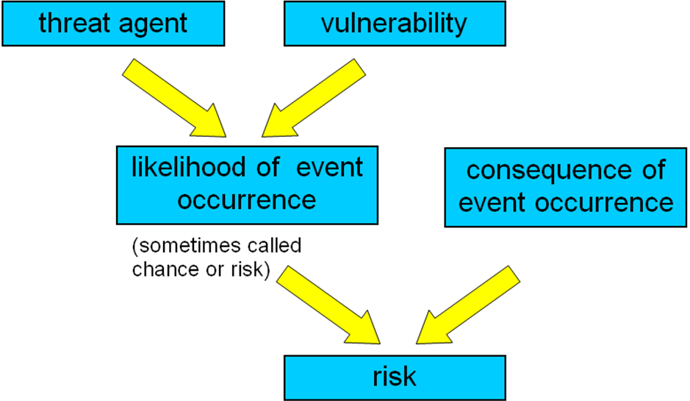

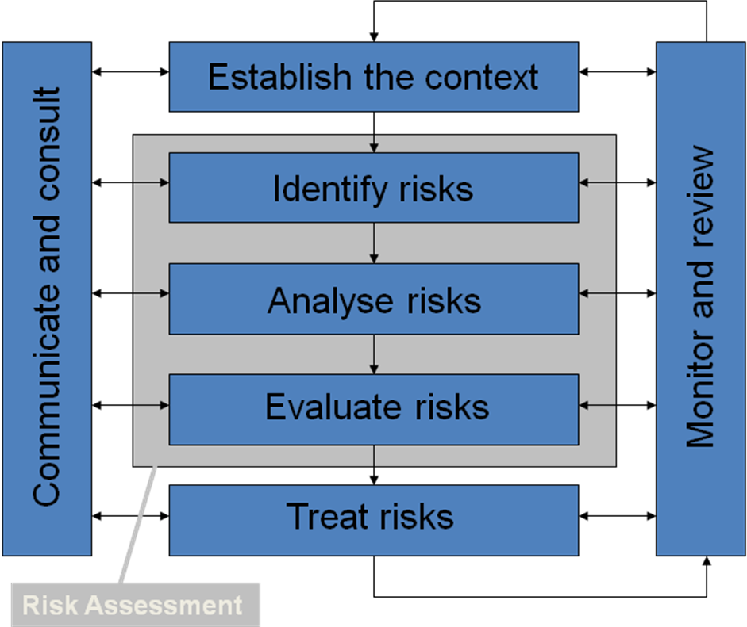
How do we manage risk?

Determine the magnitude of identified risks

Types of analysis:
- Qualitative
  - Uses descriptive scales (in words). Example:
    - Consequence: Minor, moderate, major, catastrophic
    - Likelihood: Rare, unlikely, possible, likely, almost certain
- Semi-quantitative
  - Qualitative scales assigned numerical values
  - Can be used in formulae for prioritization (with caution!)
- Quantitative
  - Use numerical values for both consequence (e.g. $$$) and likelihood (e.g. probability value)

- Calculations:
  - Single Loss Expectancy (SLE)
    - SLE = AV × EF
    - Expected $value of loss if this event happens once
  - Annualised Loss Expectancy (ALE)
    - ALE = SLE × ARO
    - Expected $value of loss for this event in one year
- CAUTION: Results obtained from these calculations are worthless if the information is unreliable or imprecise.
  - Sometimes qualitative analysis is more appropriate
- Example:
  - Risk description
    - Asset: Public image (and trust)
    - Threat: Defacing web site through intrusion
    - Impact: Loss of image
  - Parameter estimates
    - AV(public image) = $1,000,000
    - EF(public image affected by defacing) = 0.05
    - SLE = AV × EF = $50,000
    - ARO(defacing) = 2
    - ALE = SLE × ARO = $100,000
How much would you be prepared to spend on controls to deal with this threat?
- IS Management Standards: Australian
  - AS/NZS 27001:2006 Information Technology – Security Techniques -Information Security Management Systems. Requirements
  - AS/NZS 27002:2006 Information Technology - Security Techniques - Code of practice for information security management
  - AS/NZS 27005:2012 Information Technology - Security Techniques – Information security risk management
- Info Security Management Standards: International
- International (except USA):
  - ISO/IEC 27001:2005 Information Technology - Security techniques. Information security management systems. Requirements.
  - ISO/IEC 27002:2005 Information Technology – Security Techniques - Code of practice for information security management
  - ISO/IEC 27005:2011 Information Technology - Security Techniques – Information security risk management
- AS/NZS 27001:2006
- Background:
- Original information security management documents were code of practice/guidelines
- such as AS4444, based on BS7799.
- Need for a certification scheme for information security management emerged in late 1990s
- For certification purposes a general approach to security management was needed, not just a code of practice
- BS 7799.2:1999 was created to define a comprehensive Information Security Management System (ISMS) against which certification was possible.
- The concept of an ISMS is possibly more important than the original Code of Practice.
- AS/NZS 27001:2006
- A comprehensive approach to information security management
- Objective of AS/NZS 27001:2006:
- to specify requirements for establishing, implementing, operating, monitoring, reviewing, maintaining and improving an ISMS
- Use in conjunction with AS/NZS 27002:2006
- AS 27001:2006 is about management
- AS 27002:2006 is a code of practice, provides a set of information security goals and controls,
- Uses Plan-Do-Check-Act (PDCA) process model
- 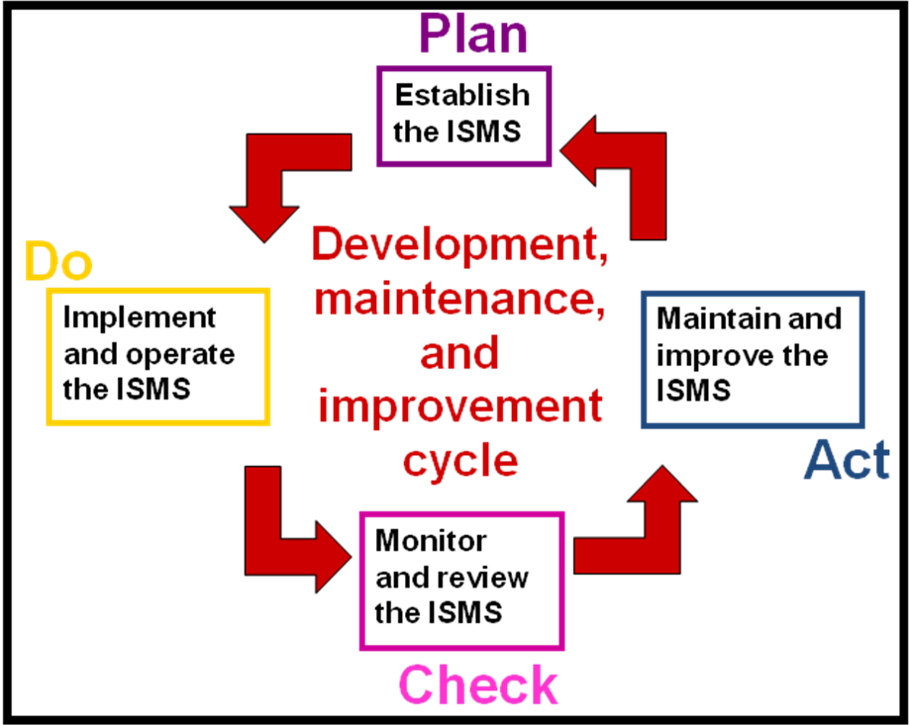

AS/NZS 27001:2006

- PLAN - Establish the ISMS
  - Purpose: Establish policy, objectives, processes and procedures
- DO - Implement and operate the ISMS
  - Purpose: Implement selected controls, and promote actions to manage identified risks
- CHECK - Monitor and review the ISMS
  - Purpose: to ensure that controls are working effectively
- ACT - Maintain and improve the ISMS
  - Purpose: Take action as a result of the Check phase
Symmetric Cryptography
- Cryptography is part of the field of study known as cryptology
- Cryptology includes both:
  - cryptography:
    - derived from the Greek, means ‘hidden writing’
    - the study of methods for secret writing:
      - transforming messages into an unintelligible form, and
      - recovering them,
using some secret knowledge.
  - cryptanalysis:
    - analysis of cryptographic systems, inputs and outputs to derive confidential information, usually without using the secret knowledge.
- Cryptographic terminology and notation:
  - Plaintext (P): the original message or data
  - Encryption (E): transformation of the plaintext into another form so that the meaning is not obvious, using an algorithm and some secret knowledge
  - Cryptographic Key (K): secret knowledge
  - Ciphertext (C): encrypted plaintext, transformed so the message is now ‘hidden’
  - Decryption (D): transformation of the ciphertext back to the original plaintext, using an algorithm and key

Lecture 3

- What is privacy?
  - “A state in which one is not observed or disturbed by other people, the state of being free from public attention”
- Clarke’s four dimensions of privacy:
  - Privacy of the person
    - Physical or bodily privacy: about the integrity of the body and consent to physical procedures
  - Privacy of personal behaviour
    - Including political, religious and sexual practices and preferences
  - Privacy of personal communications
    - Being able to communicate with other individuals without routine monitoring by others
  - Privacy of personal data
    - Control over personal data and how it will be used, even when it is held by another organisation
- Question: Do I have a right to privacy?
- Answer:
  - In Australia, there is specific privacy legislation:
    - At the federal level (Commonwealth of Australia)
      - Commonwealth Privacy Act 1988
      - Privacy amendment (Private sector) Act 2000
    - At the state level (State of Queensland)
      - Information Privacy Act 2009 (Qld)

Commonwealth Privacy Act 1988
  - Deals with privacy of personal information
    - Personal information defined as information that identifies you, or could identify you
    - Examples:
      - Name, address, date of birth, medical records, bank account details,
  - Regulates how your personal information can be collected, used, and disclosed, and how it should be maintained
  - Provides ‘principles’ rather than instructions for implementation
  - Act defines personal information as:
  - "... information or an opinion (including information or an opinion forming part of a database), whether true or not, and whether recorded in a material form or not, about an individual whose identity is apparent, or can reasonably be ascertained, from the information or opinion."

- Act applies to:
  - Commonwealth and ACT government agencies
- Act does not apply to:
  - State or Northern Territory government agencies
  - Non-government organisations
- Commonwealth and ACT gov’t agencies must comply with
  - 11 Information Privacy Principles (Section 14)
  - Tax file number guidelines (Section 17)

11 Information privacy principles (IPP)
- Manner and purpose of collection of personal information
  - Information collected for lawful purpose
  - Collection is necessary – directly related to that purpose
  - No unlawful or unfair means of collection
- Solicitation of personal information from individual concerned
  - Collector shall ensure individual knows
    - Purpose of collection
    - If authorized collection
    - Who the information will be disclosed to
- Solicitation of personal information generally
  - For personal information solicited for inclusion in a record or publication, collector should, with regard to collector’s purpose, ensure that
    - Information is relevant
    - No unreasonable intrusion on individual
- Storage and security of personal information
  - Record-keeper to ensure that
    - Record is protected against loss, unauthorised access, use, modification, disclosure, and any other misuse
- Information relating to records kept by record keeper
  - Record-keeper to ensure
    - Individual, if asks, has right to know if collector has possession of their record containing personal information – how to access
    - Access not required if refused by State law
    - Privacy Plan – nature of record, purpose, types of individuals, time period, access entitlements, steps to obtain access
    - Privacy Plan available to public and to Privacy Commissioner
- Access to records containing personal information
  - Individual concerned is entitled to access that record, except where refusal authorized by any law of the Commonwealth
- Alteration of records containing personal information
  - Record-keeper to ensure record is accurate, relevant, up-to-date, complete, not misleading
  - Allowance for correction, deletion, addition
- Record keeper to check accuracy of personal information before use
  - Record-keeper shall not use information unless accurate, up-to-date, complete
- Personal information to be used only for relevant purpose
  - Record-keeper shall not use the information except for a relevant purpose
- Limits on use of personal information
  - Record-keeper shall not use the information except for the particular purpose for which it was obtained, unless:
- Limits on disclosure of personal information
  - Record-keeper shall not disclose record to other than the individual concerned, unless:
  - Record keeper should include a note of the disclosure in the record
- Privacy amendment (Private sector) Act 2000
  - Extended coverage of the Privacy Act to cover parts of the private sector
    - including all health service providers
Exemptions from the Act include:
  - Small business with annual turnover $3 million or less
    - Some conditions on this:
      - Can’t be subsidiary of larger business, etc
      - Can’t be health service provider, etc
      - Can’t disclose personal information to others for benefit or advantage
      - Can’t be a contracted service provider for Commonwealth contract
  - Registered political parties
  - And others …
  - Includes 10 National Privacy Principles
    - Similar to the 11 Information Privacy Principles in the original Privacy Act
  - NPP1: Collection
  - NPP2: Use and disclosure
  - NPP3: Data quality
  - NPP4: Data security
  - NPP5: Openness
  - NPP6: Access and correction
  - NPP7: Identifiers
  - NPP8: Anonymity
  - NPP9: Transborder data flows
  - NPP10: Sensitive information

Threats to privacy
- People:
  - Information privacy can be threatened by actions of others, including:
    - Friends
    - Employees (Information users within organisations)
    - Employers (Management)
    - Government
    - Others?
- Technology
  - Advances in technology make collecting and processing large amounts of information possible
  - Many tools that are useful for monitoring and harvesting specific personal data, including:
    - Keystroke logging
    - Monitoring internet access - URLs visited, time spent, site visited previously
    - Monitoring email - sent, recipient, content of email
  - Monitoring user activity – keystroke logger
  - Hardware:
    - Examples: KeyGhost, Keyshark, KeyGrabber

Identity Theft
- A crime where one person uses another person’s key personal information to fraudulently impersonate them
  - The imposter uses this for their own benefit:
    - Obtain advantages that the victim has:
    - Examples: access to certain locations or services, get loans, credit cards, drivers license, rental accommodation, medical care, etc
    - Avoid penalties incurred by their actions
    - Example: failing to make loan repayments or pay credit card bills, using victim’s ID if caught speeding or other infringement, etc

- Information used to steal someone’s identity can be gained by:
  - ‘Dumpster diving’ (digging through rubbish bin contents)
    - for paper items that reveal personal information: credit card receipts, pre-approved credit forms, etc
  - Raiding letterboxes:
    - Mail may include unique identifiers such as Tax File Number
  - Social engineering
    - Phone calls, email messages, phishing scams, etc
  - Obtaining credit reports on victims

- Information used to steal someone’s identity can often be gained using online resources:
  - Personal information from public sources:
    - Personal web page, social networking sites
    - Sites that are public, but should not be:
      - December 2011 Telstra customer database example
      - March 2009 Qld pathology lab breach details of > 100 patients
  - Lists of credit card numbers available online (free & for sale)
  - Using malware to compromise a user’s PC
    - trojan keystroke logger
  - Attacking databases holding personal information

Lecture 4 - Cryptography and Symmetric Keys
Basic cryptographic system:
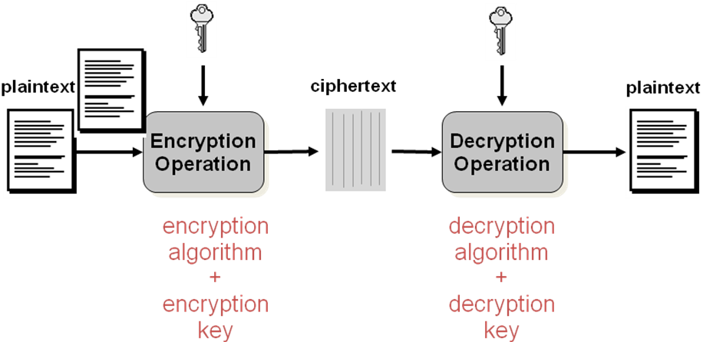

  - Encoding is the transformation of data from one form to another using an encoding algorithm.
  - Encryption is the transformation of data from one form to another using an encryption algorithm and a secret key.
    - You need to know both the corresponding decryption algorithm and the secret key to recover the data (unless the algorithm is weak, and/or you are good at cryptanalysis ☺).

What is NOT cryptography?
- Steganography: – used to hide the existence of a message
  - Hide the information within a document or image, so that the presence of the message is not detected
- Steganographic techniques include
  - Using invisible ink (try writing in lemon juice)
  - Microdots
  - Character arrangement and selection
  - Hiding information in pixels
- Steganographic techniques do not use a secret key
- Cryptographic mechanisms can be used to provide:
  - Confidentiality
    - So that your data is not made available to anyone who is not authorised to access it
      - That is, protection against snoops or eavesdroppers
  - Integrity
    - So that you can be assured the data is correct and has not been altered, either deliberately or accidentally
  - Authentication
    - So you can be sure that the message is from the place or sender it claims to be from
- Different cryptographic mechanisms provide different security services
- Ciphers are used to deliver confidentiality services for information which is
- In storage:
  - If you can’t prevent unauthorized access to data files, then encrypting the files can prevent unauthorized access to the information (that is, the attacker can’t read the file contents)
    - Example: Microsoft's Encrypting File System, BitLocker
- Being transmitted:
  - Information sent over network communication links can be encrypted to prevent eavesdroppers gaining unauthorized access to information
Example: SSL/TLS, IPSec, WEP, WPA

Cryptography and confidentiality
- Two main classes of ciphers:

Symmetric
  - The classical ciphers (example: Caesar) all fit into this category
  - Encryption and decryption keys are the same
(or one can easily be deduced from the other)
  - The cryptographic key K: must be kept secret, so has to be distributed or stored securely

Asymmetric
  - A much newer, radically different approach
  - Encryption and decryption keys are different, and disclosing one does not compromise the other
  - More on this type of cipher next week – this lecture is all about symmetric ciphers

Symmetric ciphers
- Encryption and decryption keys are the same
(or one can easily be deduced from the other)
- The cryptographic key K:
  - must be kept secret, so has to be distributed or stored securely
- The encryption and decryption algorithms are usually made public.
  - Notation:
    - Encryption: C = E(P,K)
    - Decryption: P = D(C,K)
- Two types of symmetric ciphers:
  - Stream ciphers
  - Block ciphers
Taxonomy of modern ciphers
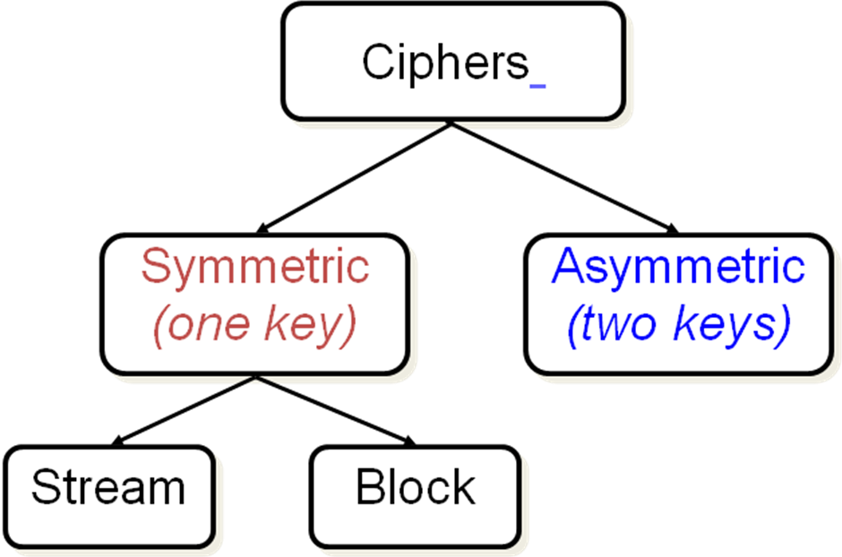

Symmetric ciphers
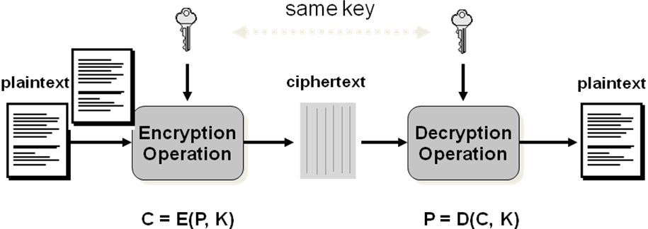

Stream ciphers
- Are symmetric ciphers where the plaintext and ciphertext are viewed as streams of characters
  - Character size may be one bit, or n-bit word e.g. 8 bit byte
- Plaintext is encrypted one character at a time, under a time-varying function of the key
- Ciphertext is decrypted one character at a time, under a time-varying function of the key
- Most common type is binary additive stream cipher
  - where plaintext, keystream and ciphertext are all streams of bits, and combining operation is just XOR

One-time pad
  - The only provably secure cipher!
  - Binary additive OTP known as Vernam OTP:
    - Plaintext is a stream of bits
    - Key is a stream of bits BUT must be
      - Truly random,
      - Same length as message, and
      - Used once only (hence the name)
    - Ciphertext obtained by binary addition (XOR) of plaintext and key
    - Plaintext recovered by binary addition (XOR) of ciphertext and key
  - NOTE: Can not reuse keys, each message you encrypt requires a new truly random key

Binary additive stream cipher example: encryption

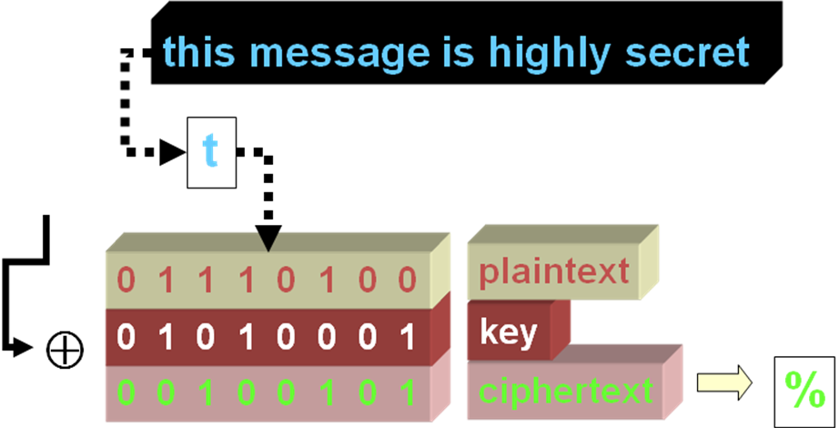

Binary additive stream cipher example: decryption

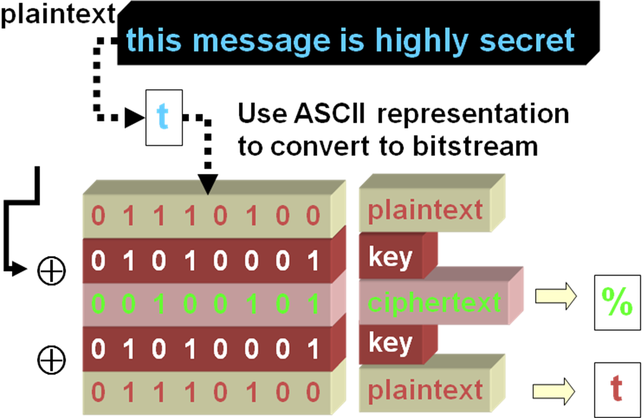

- If the attacker tries all possible keys they will recover all possible 232-bit messages, including many that are actually meaningful sentences, like:
  - Meet me at the corner shop ;)
  - The dog ate my homework today
  - I love the way the rain falls
  - You ate my chocolate cake pig
  - Where was that big black dog?
  - Aint nobody got time for that
  - Q: That’s fantastic – so why don’t we just use OTP?
  - A: There’s a practical problem: the same keystream (truly random, and same length as the message) is required for encryption and decryption of a message, and we can’t reuse keys, so
    - If you are transmitting info, can you distribute the key to the receiver securely?
    - If you are storing info, can you store this key securely?
    - So …. If you can send/store the key securely, maybe you could just send/store the original message securely?
  - Major problem is key management
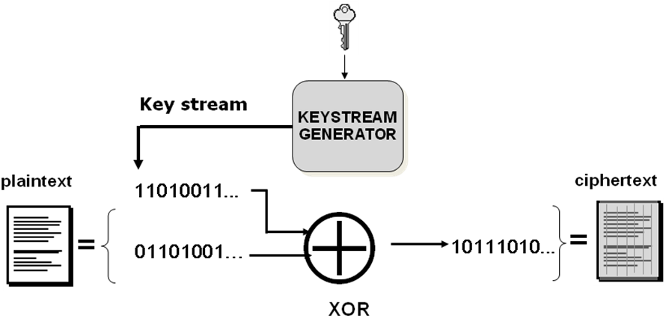
Encryption operation

- Major issue: requires synchronization
  - The keystream used to decrypt must be synchronized with the keystream used to encrypt (meaning: same keystream used in same position with respect to plaintext/ciphertext)
- What happens when there is an error?
  - Depends on the type of error:
    - If there is a bitflip error (0 to 1 or vice versa) only that bit will be decrypted incorrectly
    - If a ciphertext bit is inserted or deleted this causes a loss of synchronization, and the message can’t be recovered from the insertion/deletion point on
  - Note that the ciphers don’t provide integrity protection

- Q: How can you recover from loss of synchronization?
- At the receiving end, you could try
  - keystream offsets, or
  - request retransmission
- Alternatively, most modern stream ciphers use a secret key and known initialisation vector (IV), so that a new (different) keystream can be formed from the same key, by changing the initialisation vector
  - Common for stream ciphers used in mobile phones, or over the internet. The IV can be
    - the frame number (phone conversation), or
    - the packet number (internet communications).
- The IV is made public, only the key is secret
- Stream ciphers are fast,
  - so they are used for real-time applications where time delays may be unacceptable

Block ciphers
- The other type of symmetric ciphers
- Plaintext is encrypted one block at a time
  - Block size is usually larger than a single character,
    - common block sizes are 64-bits or 128-bits
  - In the basic block cipher mode of operation,
    - Both the plaintext block and the key are input to the encryption algorithm
    - The output of the encryption algorithm is one block of ciphertext
    - NOTE: for a fixed key, same plaintext input gives same ciphertext output
- Ciphertext is decrypted one block at a time
  - produces a block of plaintext each time
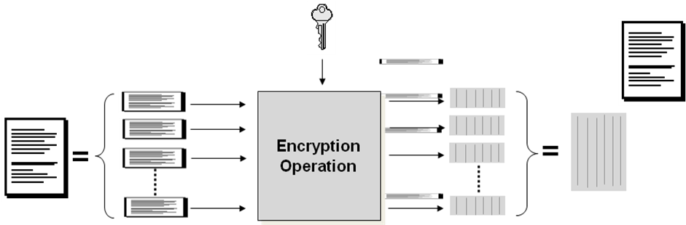

Electronic CodeBook (ECB) mode encryption
  - Simplest mode of operation
  - Plaintext data is divided into blocks P₁, P₂, …, P_{n} (last block is padded as required)
  - Each block is then processed separately
    - Plaintext block and key used as inputs to the encryption algorithm
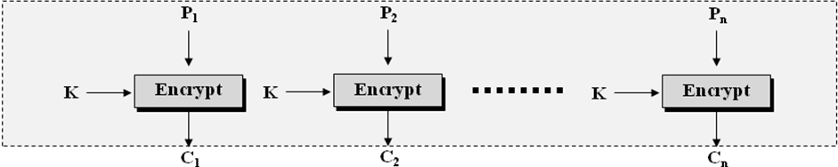

ECB mode decryption
  - Ciphertext data is divided into blocks C₁, C₂, …, C_{n}
  - Each block is then processed separately
    - Ciphertext block and key used as inputs to the decryption algorithm
    - Need to use same key as used for encryption (symmetric cipher)
  - Recovered plaintext is assembled by concatenating blocks, removing padding if required
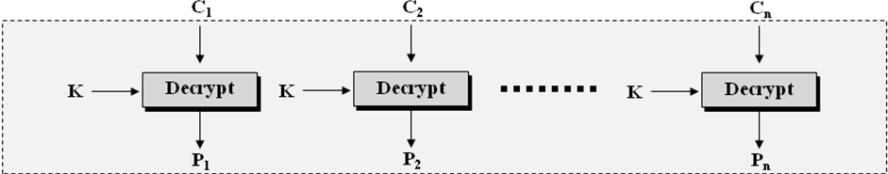

ECB Mode issues:
- What happens when there is an error?
  - For a bitflip error (0 to 1 or vice versa) that block will decrypt incorrectly
  - If a ciphertext bit, or even a character, is inserted or deleted this will be detected because of the incorrect ciphertext length
    - But ECB mode won’t detect insertion or deletion in multiples of the block size
- Another Problem:
  - For a given key, the same plaintext block always encrypts to the same ciphertext block.
    - Attacker may construct a code book of known plaintext/ciphertext blocks
    - Attacker could use this codebook to insert, delete, reorder or replay data blocks within the data stream without detection
  - To prevent this, need to ensure that if the same plaintext block is encrypted multiple times, the ciphertext formed may be different each time

Cipher Block Chaining (CBC) mode encryption
  - Plaintext data is divided into blocks P₁, P₂, …, P_{n}
(last block is padded as necessary)
  - The encryption algorithm now takes three inputs:
    - the key, the plaintext, and the previous ciphertext
    - For the first plaintext block, an initialisation vector (IV) is used to ensure that two encryptions of the same plaintext will result in different ciphertext.
  - Encryption:
C₁ = E(P₁ ⊕ IV, K)
C_{i} = E(P_{i} ⊕ C_{i-1} ,K)

CBC Mode Issues
  - The chaining guards against the construction of a code book
    - Now if the same plaintext block is encrypted, it may form different ciphertext blocks.
  - Chaining may also assist in detecting integrity breaches
    - such as insertion, deletion or reordering of data blocks in the ciphertext.
- What happens in CBC mode when there is an error?
  - If there is a bitflip error (0 to 1 or vice versa) that block and one bit in the following block will be decrypted incorrectly
  - If a ciphertext bit, or even a character is inserted or deleted this will still be detected because of the incorrect ciphertext length
    - But the length alone will not be enough to detect if the number of bits inserted/deleted is a multiple of the block size
  - However, inserting or deleting a block will cause incorrect decryption
- Q: How can you check integrity?
- Two methods commonly used to provide assurances of the integrity:
  - Hash functions
    - These are often used in information security applications
    - However, dedicated hash functions don’t require the use of a secret key
      - Need to understand appropriate use and limitations
  - Block ciphers (in certain modes)
- Stream ciphers can also be used for integrity assurance,
  - BUT this is a newer and not yet fully explored research area – so not included in this lecture

Hash functions
- A hash function H is a transformation:
  - takes as input a message M of arbitrary length
  - produces as output the fixed-length value H(M)
- H(M) is called the hash value
  - (or message digest, or checksum)
- Widely used hash functions include MD4, MD5, and SHA-1.
  - MD4 and MD5 produce 128-bit hash values
  - SHA-1 produces a 160-bit hash value
- In 2012 NIST hash function competition winner Keccak chosen as SHA-3 to provide an alternative to SHA-1 and SHA-2

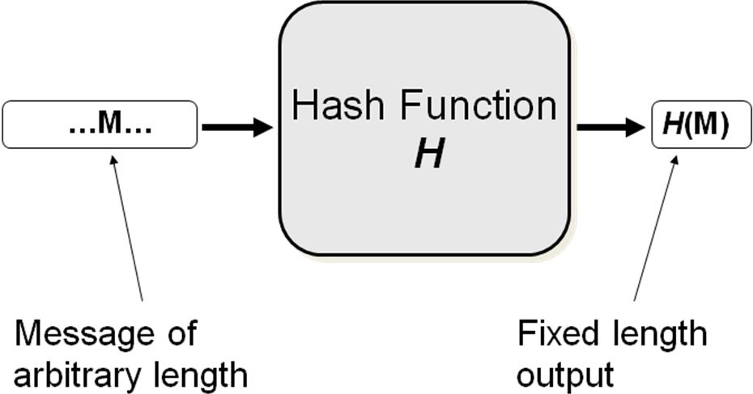

- Four basic properties:
  - H1: Fixed length output H(M),
for arbitrary length input M
  - H2: H(M) is one-way:
    - given M, it is easy to compute H(M), but given H(M), it is infeasible to compute M
  - H3: H(M) is collision-resistant:
    - Hard to find two messages M and M’ so that H(M) = H(M’)
  - H4: If you make a small change in M, it produces a major change in H(M)

Keyed hash functions
  - Also called cryptographic checksums or message authentication codes (MAC)
  - A hash function H_{K}(M) with two inputs:
    - Message M
    - Cryptographic key K
  - Secret key protects against unauthorized modification of the hash value
    - Calculating H_{K}(M) value requires knowledge of secret key.
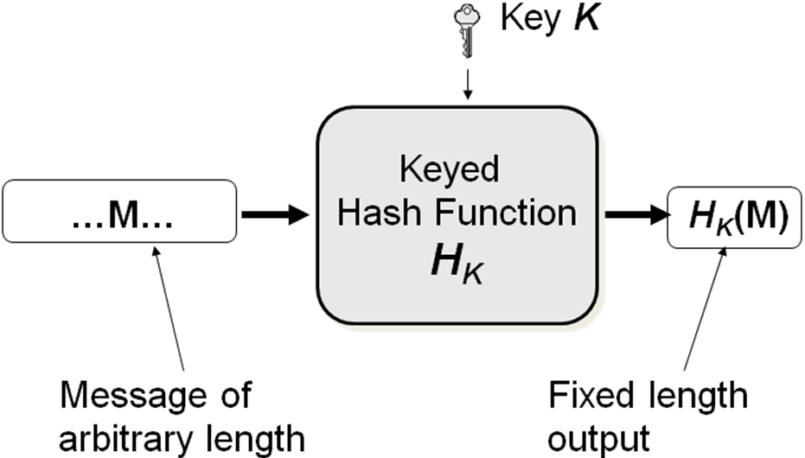
    - Attacker can only successfully modify information and update the H_{K}(M) value appropriately if they know the key.

- Using a keyed hash function to provide integrity services during transmission:
  - Sender:
    - Generates message M,
    - Generates MAC = H_{K}(M) from M, using K (shared secret key)
    - Sends { M, MAC } to Receiver
  - Receiver:
    - Receives {M’, MAC},
    - Generates MAC’ from M’, using K (shared secret key)
    - Compares MAC’ and MAC
    - If MAC’ ≠ MAC then knows the message has been altered, but if MAC’ = MAC assumes that message is unaltered
Keyed hash functions
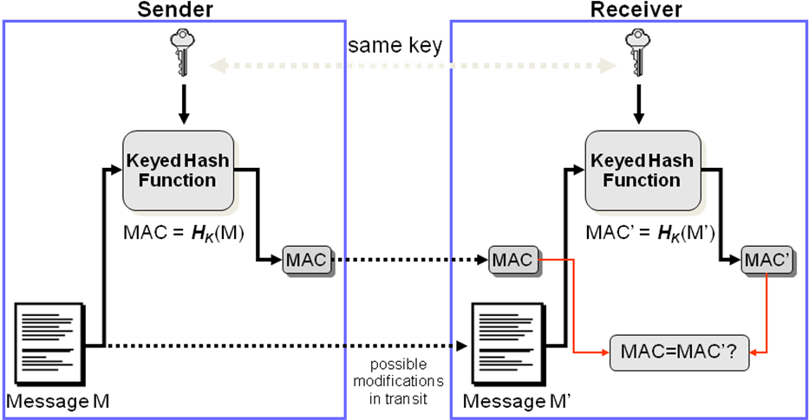

- Using a block cipher in CBC mode can provide integrity assurance, rather than confidentiality
  - For a given message or data file:
    - The file is encrypted using the block cipher in CBC mode
    - The last ciphertext block is used as a Message Authentication Code (MAC) value
    - Both the message and the MAC are sent to the receiver
  - Usually referred to as CBC-MAC
    - Described in ISO/IEC 9797-1:1999
  - Considered secure for messages of a pre-selected fixed length

Block Ciphers and Integrity assurance
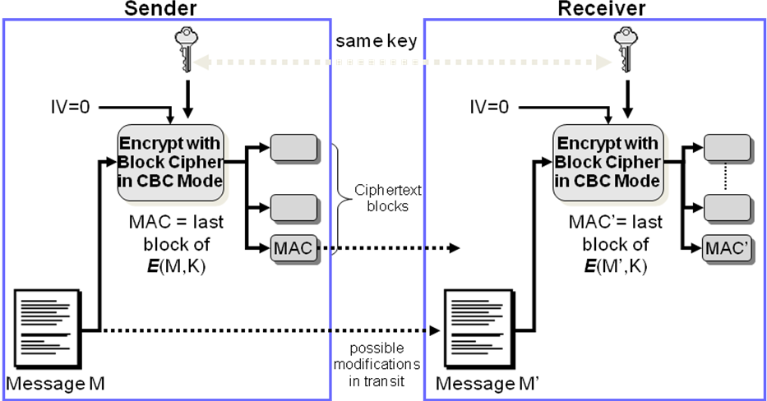

- To use a block cipher in CBC mode for integrity assurance:
  - Sender:
    - Generates message M
    - Encrypts message M using block cipher in CBC mode, using shared secret key K
    - MAC = last ciphertext block (discard the other c/text blocks)
    - Sends both M and MAC to Receiver
  - Receiver:
    - Receives {M’, MAC}
    - Generates MAC’ from M’
    - Compares MAC’ and MAC
      - If MAC’ = MAC assume M’ = M, i.e. message is unaltered

Integrity assurance and Message authentication
- HMAC and CBC-MAC use shared secret keys
- For message transmission scenarios, these MACs provide an additional security service of Message Authentication:
  - A correct MAC value confirms the sender of the message is in possession of the shared secret key
  - Hence, much like a password, it provides the receiver with some assurance of the authenticity of the message sender.
- NOTE: An assurance of message integrity is meaningless without knowing who sent the message.

- Symmetric ciphers → same key is used for both encrypting and decrypting.
- Storage scenarios:
  - To store a file encrypted using a symmetric cipher for confidentiality protection, and then retrieve it later for use, the secret key must also be stored.
    - How can we store the secret key securely until it is required?
- Transmission scenarios:
  - For two parties to communicate confidentially using a symmetric cipher, they must both share a secret key.
    - How can we establish and distribute this shared symmetric key securely before communication begins?

- Security services provided by ciphers depend on the security of the key - Cryptographic techniques provide no security if the key is compromised!
- The security of the symmetric key involves:
  - Confidentiality:
    - The key must only be available to those authorized to use it.
  - Integrity:
    - If a key is altered, then the altered key will not decrypt ciphertext formed using the original key.
    - If an attacker alters the key (replaces it with a key they know) then potentially they have unauthorized access to all information that is encrypted with the new key.
  - Availability:
    - If an attacker destroys a stored key, all information currently encrypted with that key will be unavailable.
- Cryptography in the standards:
  - Section 12.3 of AS27002:6 deals with cryptographic controls.
  - The stated objective of this section is:
    - To protect the confidentiality, authenticity or integrity of information by cryptographic means.
  - The section consists of:
    - 12.3.1 Policy on the use of cryptographic controls
      - With implementation guidance and other information
    - 12.3.2 Key management
      - This is essential for the effective use of cryptographic techniques
Summary
- What cryptography is and when it is used
- There is a ‘perfect’ cipher (OTP), but it has serious limitations (what is it perfect for, and what does this require?)
- There are practical symmetric ciphers
  - Stream ciphers
  - Block ciphers
and a bit about when to use these ciphers
- What hash functions are and how to use them
- The security services symmetric ciphers provide depends on the security of the shared secret key

Lecture 5 – Access Control

Q: What is access control?
A: Controlling how users and systems access other systems and resources:
  - To prevent unauthorised users gaining access to resources
  - To prevent authorised users from misusing resources
Q: Why is access control important for information security?
A: Unauthorised access could compromise
  - Confidentiality
  - Integrity
  - Availability
of information assets
  - these are valuable assets and should be protected
  - Main types of cyber incidents reported:
    - theft of a notebook, tablet or mobile devices (32%)
    - virus or worm infection (28%)
    - trojan or rootkit malware (21%)
    - unauthorised access (18%)
    - theft or breach of confidential information (17%)
    - denial-of-service attack (16%).

- For effective access control, you need to consider:
  - What resources do you have?
  - How sensitive are these resources?
  - Who should have access to each resource?
  - What access permissions (authorisations) should they have?
  - How will access control decisions be made?
  - How will your access control policy be implemented?

What resources do you have?
- First step is to form an inventory:
  - Useful for other purposes – insurance, risk management etc.
  - AS/NZS 27002:2006 Clause 7 Asset management includes this in subsect. 7.1 Responsibility for Assets
    - 7.1.1 Inventory of assets
      - Include type, format, location, backup information, license information and business value of all assets
    - 7.1.2 Ownership of assets
    - 7.1.3 Acceptable use of assets
      - Including rules for email and internet use, and guidelines for the use of mobile devices

How sensitive are these resources?
- Assess the sensitivity of each resource:
  - AS/NZS 27002:2006 Clause 7 Asset management includes this in subsect. 7.2 Information classification
    - 7.2.1 Classification guidelines
      - Classify info in terms of its value, legal requirements, sensitivity and criticality to the organization
      - Take into account business needs for sharing or restricting information and the business impact associated with these needs
      - Classification may vary over time – review and reclassify
    - 7.2.2 Information handling and labelling
      - Includes procedures for information labelling particularly of sensitive or critical material

Who should have access to each resource?
- Common principles for access control policies are:
  - blacklists
    - Access generally permitted unless expressly forbidden
      - If your name is on the list, you will be denied access
      - These are the sites that you are not permitted to visit
  - whitelists
    - Access is generally forbidden unless expressly permitted
      - If your name is on the list, you will be granted access
      - These are the only sites that you are permitted to visit

Who should have access to each resource?
- Common principles for access control policies:
  - principle of least privilege
    - Access is generally restricted to the minimum resources and authorisations required for an entity to perform their day-to-day function
    - Intended to limit the level of damage if a security incident occurs
    - Where the resource is information, may be known as need to know principle
      - Only given information needed now to perform your job
  - Separation of duties (privileges):
  - For any critical task,
    - Divide the task up into a series of steps
    - Ensure that the steps are performed by different entities
      - No single entity should be authorised to complete all of the steps in a critical task
    - More than one entity is now required to complete the task
      - Useful to minimise error, harder for insider abuse, for example fraud

Access control terminology:
  - Subjects
    - Entities requesting access to a resource
      - Examples: Person (User), Process, Device
    - This is an active role:
      - Entity initiates access request and is user of information
  - Objects
    - Resources or entities which contain information
      - Examples: Disks, files, records, directories
    - This is a passive role
      - Object is repository for information, the resources that a subject tries to access

What access permissions (authorisations) should subjects have?
  - What modes of access are permitted?
- If you have permission to access a resource, what are you allowed to do to the resource?
  - Example: possible access permissions for data resources include
    - read - observe
    - write – observe and alter
    - execute – neither observe nor alter
    - append – alter
    - search

How will access control decisions be made?
- Three main approaches:
  - Discretionary access control
    - Decision at the discretion of some individual, possibly the information asset owner
  - Mandatory access control
    - System wide set of rules applied
  - Role-based access control
    - Decision based on the role of the individual, rather than the identity (user, administrator, student, etc)

How will the access control policy be implemented?
- To implement a system where some subjects are permitted to access a restricted resource, need to be able to
  - Identify the subject
    - Who are you claiming to be?
  - Authenticate the subject
    - Provide evidence that you are who you claim to be
  - Verify that the subject is authorized for the requested mode of access
- Consider control mechanisms to enforce the access control policy for the resource being protected
  - Just having a policy doesn’t mean users will abide by it

Discretionary access control
  - Access rights to an object or resource are granted at the discretion of the owner
    - For example, the security administrator, the owner of the resource, or the person who created the asset
  - DAC is discretionary in the sense that a subject with a certain access authorization is capable of passing that authorization (directly or indirectly) to any other subject.
  - Often implemented access control lists or matrices
  - Popular operating systems use DAC.

Mandatory access control
  - A central authority assigns attributes to objects and to subjects
    - For example: clearance and classification levels
  - A system-wide set of rules is formed relating the attributes of the objects and subjects to the modes of access that are permitted
  - MAC is mandatory in the sense that entities are not able to decide which other entities they want to allow to access resources, the system rules apply
    - the system denies users full control over access to the resources they create

Role based access control
  - Access rights are based on the role of the subject, rather than the subject’s individual identity
    - A role is a collection of procedures or jobs that the subject performs
      - Examples: user, administrator, student, etc
    - A subject could have more than one role
      - Example: Chai Wen is a student and a staff member
    - More than one subject could have the same role
      - Example: Lots of students!

Implementing access control
- Two phases of access control:
  - Policy definition (authorisation) phase where privilege is allocated and administered
    - Authorise subject by defining the AC policy
    - Distribute access credentials/token to subject
    - Change/revoke authorisation whenever necessary
  - Policy enforcement (grant access) phase* where privilege is required to gain access
    - Authenticate subject
    - Grant access as authorised by policy
    - Monitor access
    - (note: sometimes the term “authorisation” is used for this phase)

Phase 1 - Administration of privileges
  - How are users informed of
    - their access privileges?
    - their responsibilities w.r.t. these privileges?
  - How do you
    - give users the means to exercise their privileges (credentials)?
    - revoke (take back the means to exercise) their privileges?
  - Who keeps track of who has what?
    - Recording privileges
- Access control:
  - 11.2 User access management
  - Objective: To prevent unauthorized access to information systems.
  - Formal procedures in place to control allocation of access rights ... to cover all stages … from initial registration of new users to the final deregistration of users who no longer require access ...
  - 11.2.1 User registration
  - 11.2.2 Privilege management
  - 11.2.3 User password management
  - 11.2.4 Review of user access rights

Phase 2 - Policy enforcement
- To gain access to a resource, users should be authenticated and authorised
  - Authentication permits the system to verify you are the identity you claim to be
    - Identification: the process of claiming an identity
    - (Entity) Authentication: the process of proving (validating or verifying) the claimed identity
  - Examples:
    - You announce who you are, and show your ID card
    - You provide a user ID, and the corresponding password
  - The system checks if you are authorised for the requested access (from Phase 1) before granting access
- Identification and authentication of users is important because:
  - User identity is used to make access control decisions
  - User identity is recorded in logs of events in an audit trail
- The system needs to be assured that
  - attackers cannot masquerade as legitimate users
- Users need to be assured that:
  - they are communicating with legitimate systems
  - the system does not allow masquerade attacks (which could result in their being held responsible for the actions of an attacker), and
  - the system itself cannot subsequently masquerade as the user

- 10.10 Monitoring
  - Objective: Detect unauthorized information processing activities
    - 10.10.1 Audit logging
    - 10.10.2 Monitoring system use
    - 10.10.3 Protection of log information
    - 10.10.4 Administrator and operator logs
    - 10.10.5 Fault logging
    - 10.10.6 Clock synchronization

User authentication
- Authenticators can be categorised as:
  - Knowledge-Based (Something you know)
  - Object-Based (Something you have)
  - ID-Based (Something you are)
  - Location-based (Somewhere you are)
- Multi-factor authentication uses combinations of the above categories of authenticators

Knowledge-Based (Something you know):
  - Characterized by secrecy or obscurity
    - something only you would know
  - Examples:
    - memorized passwords
    - responses to questions:
      - your birthdate,
      - Mother’s maiden name,
      - or your pet’s name
  - Advantages include:
    - Readily accepted method
    - Easily implemented
  - Disadvantages include:
    - Can be shared with others by user
    - User may forget password
    - May be compromised without user knowledge
      - Others may know or be able to guess
      - Difficult for user to know if compromised

Object-Based (Something you have):
  - Characterized by physical possession of a token.
  - Examples:
    - Physical key
    - Magnetic swipe card
    - Token used for generating access codes
  - Advantages include:
    - Difficult to share (effort required to make a copy)
    - If lost, the owner may realise - sees evidence of the loss
  - Disadvantages include:
    - If lost, the finder can make use of the token
    - May be difficult or expensive to recall without cooperation of user

ID-Based (Something you are):
  - Characterized by uniqueness to one person.
  - Examples include:
    - fingerprint,
    - eye scan (iris or retina),
    - voiceprint,
    - physical signature
  - Advantages include:
    - Characteristic can’t be forgotten or lost
    - May be difficult to copy, share or distribute
    - Should require the person being authenticated to be present at the time and point of authentication
  - Disadvantages include:
    - System to implement this may be complex
    - Characteristic may not be ‘secret’: others may be able to produce sample
    - Harder to replace a compromised biometric authenticator, than to replace passwords or tokens

Location-based (Somewhere you are):
  - Characterized by your location
    - space and/or time
  - Examples:
    - Use of location and tracking technologies
      - triangulation of cell-phone signals, or global positioning systems (GPS).
    - Machine IP address and DNS name
    - Link location to time
  - Advantages include:
    - Can improve network security, if access locations are (relatively) local
  - Disadvantages include:
    - Privacy issues
      - who should know where you are, when?

Multi-factor authentication
  - combines two or more authentication techniques
  - Aim is to obtain a stronger and more reliable level of authentication
- Typical example:
  - Two-factor authentication is commonly based on
    - something a user knows (factor one), plus
    - something the user has (factor two).
  - This is often the combination of a password and a token
    - Example: ATM card and PIN

Lecture 6 - Access Control Mechanisms
- Most access control decisions are based on user identity
- Need to have:
  - A unique identifier for each individual
  - A means by which the identity can be verified
    - This process is called user authentication
- User authentication is fundamental for:
  - access control
user accountability

Access control process:
  - Identification: the entity requesting access presents an identifier to the system
  - Authentication: the entity requesting access provides information that enables the system to verify the claimed identity
  - Authorisation: the system checks that the authenticated entity is authorised for the requested access
- If authenticated entity is authorised for type of access requested, access to resource is granted

Knowledge-Based (Something you know):
  - Characterized by secrecy or obscurity
    - something only you would know
  - Examples:
    - memorized passwords
    - responses to questions: your birth date, mother’s maiden name, favourite food, your pet’s name, etc
  - Advantages include:
    - Readily accepted method, low cost implementation
  - Disadvantages include:
    - Can be shared
    - Difficult for user to know if compromised

Object-Based (Something you have):
  - Characterized by physical possession of a token.
  - Examples:
    - Physical key
    - Magnetic swipe card
    - Token used for generating access codes
  - Advantages include:
    - Difficult to share (effort required to make a copy)
    - If lost, the owner may realise - sees evidence of the loss
  - Disadvantages include:
    - If lost, the finder can make use of the token

ID-Based (Something you are):
  - Characterized by uniqueness to one person.
  - Examples include:
    - biometrics such as fingerprint, eye scan, voiceprint, signature
  - Advantages include:
    - Characteristic can’t be forgotten or lost
    - May be difficult to copy, share or distribute
    - Should require the person being authenticated to be present at the time and point of authentication
  - Disadvantages include:
    - Harder to replace a compromised biometric authenticator, than to replace passwords or tokens

Location-based (Somewhere you are)
  - Characterized by your location (space and time?)
  - Examples:
    - Use of location and tracking technologies: triangulation of cell-phone signals, or global positioning systems (GPS).
    - Machine IP address and DNS name
    - Link location to time
  - Advantages include:
    - Can improve network security, if access locations are (relatively) local
  - Disadvantages include:
    - Privacy issues – who should know where you are, when?

Knowledge based: Passwords
- Reusable passwords
  - the most commonly used authenticator
- User provides:
  - username or ID, and
  - password
- System has prior stored value to compare with
  - Successful provision of required value authenticates user to system
- Requirement: system must store the values used to verify the passwords for all system users
- Problems:
  - Can be easy for user to
    - share (intentionally or not), or
    - forget
  - Can be written down (post-it note on monitor?)
  - Can be easy for attacker to guess
  - No non-repudiation if password is known to system
  - System password files are valuable information assets, so password files need to be protected
    - should not be stored with passwords as plaintext
- Password selection strategies
  - User selected, or
  - Computer generated
- Password checking
  - Reactive password checking
  - Proactive password checking

Protecting Passwords
- For user selected passwords, organisation’s security policy should include:
  - User training
    - Explain to users the importance of choosing ‘strong’ passwords.
  - Password selection guidelines
    - What are the characteristics of ‘good’ passwords?
    - AS27002:2006 Clause11.3.1 has guidelines for password use.
- Unlikely to be effective in most organisations
  - particularly with large user population or a high turnover of users.
- Some users simply ignore guidelines, or are poor at selecting a ‘strong’ password.
  - Many choose passwords that are too short and very easy to guess.

Reactive password checking:
  - System administrator periodically runs a password cracking tool (those available to attackers) on password file looking for those passwords that are easy to recover
    - How often should the administrator do this?
    - Is this activity approved by management?
    - Is there an ‘evil’ side to this?
  - What type of passwords are “easy to recover”?
  - What type of passwords are “easy to recover”?
    - Short passwords
      - Easy to check all possible combinations of 3 or 4 characters
    - Passwords that are dictionary words …
      - Users more likely to use apple than plape
    - Or words with an alpha character replaced with digit …
      - Say, appl3
- Reactive checking does not prevent
  - users choosing bad passwords, or
  - using them until detected and asked to change

Proactive password checking:
  - The user selects a potential password
  - This is tested to see if it is strong enough to be used
    - If the password is unsuitable, the user must choose again
  - Balance is required:
    - If the system rejects too many potential passwords, the users will complain about the process
    - If the acceptable password criteria are too ‘simple’, this may aid attackers by allowing a refined search over a smaller password space than might otherwise have been the case

Protecting passwords
  - Reusable passwords require confidentiality when in
    - Storage (on authentication server)
    - Transmission (between client and server over network)
    - Use (do not display on screen when being entered!)
  - If ‘clear’ passwords are captured, an attacker may reuse the password and masquerade as the user
    - Http basic authentication effectively transmits ‘clear’ passwords
  - OR an attacker may masquerade as the server, so that the client will disclose the ‘clear’ password to the rogue server
- Reusable passwords & storage strategies:
  - System password file has entries for each user:
    - Example: Leonie myPassw0rd
  - Alternatives to storing plaintext passwords?
  - Store the hash values of passwords
    - Example: Leonie a422be0e206a05bf03061140e4942382
    - Attacker needs to find a password that produces this value
    - Suppose I see Mark a422be0e206a05bf03061140e4942382 in the password file, and I know what my password hash is?
  - Store salted hash values of passwords
    - Put some random but not secret information in to pwd hash
    - Example: Leonie 86 427b050a20b5eb9301a6957c80a7e9b5

Use encryption
- One-Time Password authentication systems
  - aim to provide security against attacks based on replaying captured reusable passwords
- However:
  - eavesdropping attackers may be able to exploit race conditions if multiple simultaneous authentication sessions are allowed
  - One-Time Password does not provide
    - confidentiality or data integrity services
    - protection against active attacks such as session hijacking
      - known to be present in the current Internet
- One-Time Password authentication systems
- S/KEY (developed by Bellcore around 1994) provides basis for deriving OneTime Passwords
- OneTime Password described in RFC 2289 (1998) http://www.faqs.org/rfcs/rfc2289.html
  - Uses a secret pass-phrase to generate a sequence of one-time (single use) passwords
  - Password sequence is generated by applying a hash function:
    - To the password P,
    - Then to the hash value H(P)
    - Then to that hash value H(H(P)) …
  - The passwords are used in the reverse order to generation
  - The system only needs to store the password provided in order to verify the next password
  - Security of this One Time Password system is based on the difficulty of inverting a secure cryptographic hash function

Object based: Tokens
- Clock-based tokens: Operation
- Token display shows a constantly changing value
  - Clock time is used as input to algorithm calculating display value
  - User provides ID and then types in current value as authenticator when requesting access (log in to system)
- Possession of token is necessary to know the correct value for the current time
- NOTE: Clocks in token and at host system must be synchronised
- Some tokens have extra security feature: require a PIN to access display value
  - Something you have, or something you know?
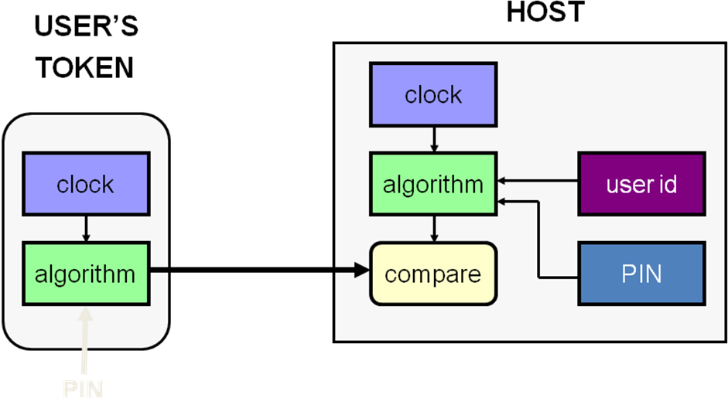

- Example: RSA SecurID
- Each RSA SecurID authenticator has a unique symmetric key (uses cryptography)
- The key is used with a proprietary algorithm (SecurID Hash) to generate a new code every 30/60 seconds
- The code is unpredictable and dynamic
  - Difficult to guess the correct code at any given time.
- Clock-based tokens: Issues
- Requires synchronisation:
  - The system fails if clocks in token and at host are not synchronised
- For network usage, need to provide an acceptable window of time to allow for network delays
  - Introduces the possibility of attack
    - An intermediate node could capture a password and then log in as user
- Counter-based tokens: Operation
- Instead of a clock value, the token device generates a ‘password’ result value as a function of an internal counter and other internal data, without external inputs.
- Example: HOTP
  - HMAC-Based One-Time Password Algorithm
  - described in RFC 4226 (Dec 2005)
    - http://www.rfc-archive.org/getrfc.php?rfc=4226
  - Uses a shared secret value (stored on token) as shared key
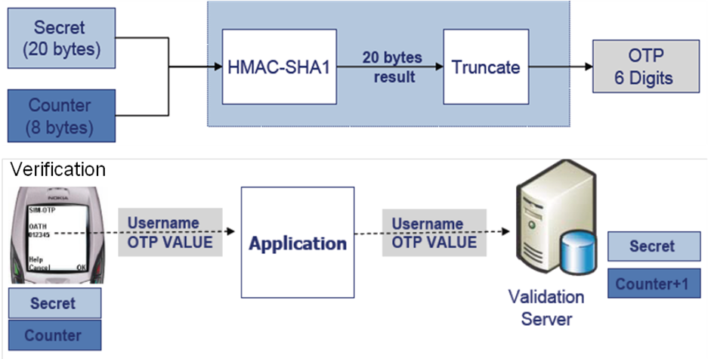
  - Value displayed on the token is HMAC value of the current counter value

ID based: Biometrics
- What is a biometric system?
  - Automated methods of verifying or recognising a person based upon a physiological or behavioural characteristic.
- Biometric examples:
  - fingerprint
  - facial recognition
  - eye retina/iris scanning
  - hand geometry
  - written signature
  - voice print
  - keystroke dynamics

- Requirements for biometric characteristics:
  - Universality:
    - each person should have the characteristic
  - Distinctiveness:
    - any two persons should be sufficiently different in terms of the characteristic
  - Permanence:
    - the characteristic should be sufficiently invariant (with respect to the matching criterion) over a period of time
  - Collectability:
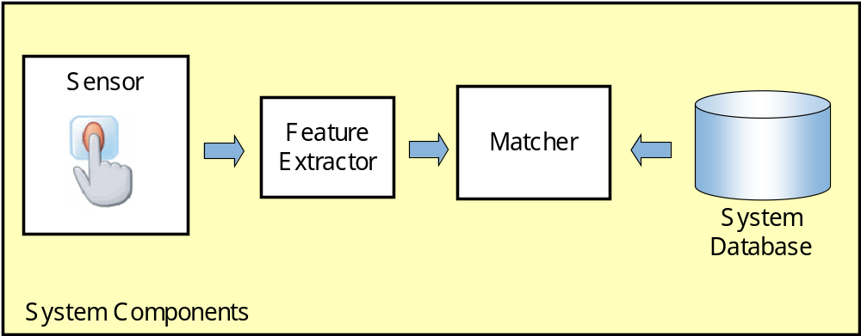
    - the characteristic can be measured quantitatively

  - Sensor module: captures the biometric signal of an individual.
    - Example: fingerprint sensor that images the ridge and valley structure of a user’s finger.
  - Feature extraction module: processes the acquired biometric signal to extract a set of discriminatory features.
    - Example: feature extraction module of a fingerprint-based biometric system extracts the position and orientation of minutiae points (local ridge and valley singularities) in a fingerprint image.
- System components:
  - System database module: used to store the biometric templates of enrolled users
  - Users are included in biometric system database in enrolment phase:
    - Biometric characteristic of individuals scanned by a biometric reader to produce a digital representation (feature values) of the characteristic.
    - Quality check performed to ensure acquired sample can be reliably processed by successive stages.
    - Input digital representation is further processed by a feature extractor to generate a compact representation called a template.
    - May store multiple templates to account for variations
- Modes of operation:
- Enrolment:
    - Analog capture of the user’s biometric attribute.
    - Processing captured data to develop a template of user’s attribute
- Verification of claimed identity (1-to-1):
    - Capture of a new biometric sample.
    - Comparison of the new sample with that of the user’s stored template.
    - Decision on access acceptance or rejection.
- Identification (1-to-many):
    - Capture of a new biometric sample.
    - Search database of stored templates for a match based solely on the biometric.
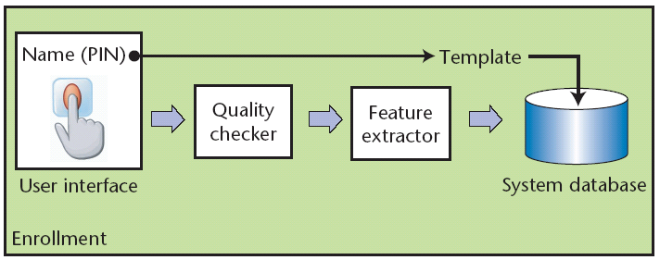
ID based: Biometrics - Enrolment

ID based: Biometrics - Verification
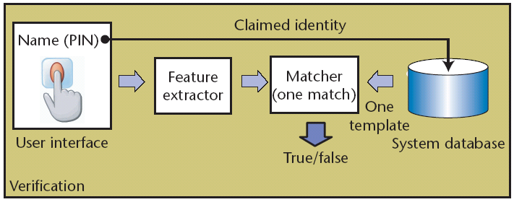

ID based: Biometrics - Identification
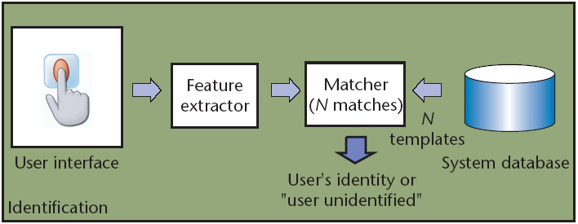

- So biometric verification systems can make two types of errors in decision making:
  - False match:
    - mistaking biometric measurements from two different persons to be from the same person, (results in allowing unauthorised person access) and
  - False non-match:
    - mistaking two biometric measurements from the same person to be from two different persons (so rejecting legitimate user)
  - There is a trade-off between false match rate (FMR) and false non-match rate (FNMR) in every biometric system
- The system decision is tuned by a threshold t:
  - Pairs of biometric samples generating matching scores higher than or equal to t are inferred as mate pairs (same person);
  - Pairs of biometric samples generating scores lower than t are inferred as non-mate pairs (different persons).
- Both FMR and FNMR are functions of the system threshold t:
  - If t is decreased to make the system more tolerant to input variations and noise, then FMR increases
  - If t is raised to make the system more secure, then FNMR increases accordingly
Summary
- Access control is important in information security
  - Access to resources may be restricted – decision to allow access depends on identity of requester
- User authentication is fundamental - want to
  - prevent unauthorised access, and
  - permit authorised access to information assets
- Common access control mechanisms are
  - Knowledge based - Passwords
  - Object-Based - Tokens
  - ID-Based - Biometrics
- Some mechanisms require cryptography
- Advantages and disadvantages for each type
  - Cost, level of security provided, user acceptability, etc

Lecture 7 – Asymmetric

Symmetric Ciphers
  - used to provide security services such as:
    - Confidentiality
    - Integrity
  - use the same secret key to encrypt and decrypt
    - For transmission of encrypted messages, key required at sending and receiving points,
    - For encrypted storage, key required at storage and retrieval
- Key establishment options:
  - Generate and securely pre-distribute shared keys for likely communicants
    - Possible for a small group (see next slide)
  - Use a trusted third party (as a key server)
    - who shares a (long-term) symmetric key with each user, and can provide a shared key for any two parties upon request
      - Example: Kerberos protocol
  - Diffie-Hellman key agreement algorithm
    - Allows 2 hosts to create a shared secret (form a secret key) without a secure distribution channel

Option 1 – Secure pre-distribution
  - Secret key distribution must happen ‘out-of-band’:
    - Not over the communication channel, but over a different secure channel.
    - Maybe physical distribution via trusted courier?
- How many secret keys are needed in a system?
  - If there are
    - two people, only one secret key is needed.
    - three people, and each participant may possibly communicate securely with every other participant, three secret keys are needed.
    - four people, six secret keys are needed
    - n people, n(n-1)/2 secret keys are needed

Option 2 – Trusted third party
  - Alternative to everyone having a secret key for possible communications with everyone else:
    - have one trusted party
    - everyone holds shared secret keys to communicate with that party
  - When you want to communicate securely with someone else:
    - you ask the trusted third party (TTP) to send you a key (encrypted using the secret key you share with the third party)
    - You use this key in communications with the other party
    - Kerberos is a well known scheme that takes this approach

Option 3 – Diffie-Hellman key agreement alg’thm
  - 1976: Whitfield Diffie and Martin Hellman published a radical method for forming symmetric cryptographic keys
  - Made use of certain mathematical methods:
    - modular exponentiation, with careful parameter choices
  - Without prior arrangement, two parties without a secure distribution channel can agree on shared secret known only to them
    - Each sends the other a mathematical function of their chosen secret, and these can be combined to form shared secret
    - An eavesdropper cannot determine the shared secret by listening to the messages exchanged by the two parties
      - unless they can break the discrete log problem
Q: Does that mean Alice and Bob can now:
    - establish a shared secret key over an insecure channel (yes),
    - and can communicate securely, without worrying about Carol (the attacker)?
  - A: Actually, no.
    - If Carol is clever, she can still eavesdrop …
    - Problem is there is no authentication of the communicating parties. Alice and Bob have no assurance about who they are communicating with, so a man-in-the-middle (Carol) attack is possible
  - Important aspect of Diffie-Hellman is application of a new type of mathematics in cryptography: lead to asymmetric cipher systems

Asymmetric ciphers
- Symmetric encryption and decryption keys are the same
- Asymmetric encryption and decryption keys are different:
  - The keys are related, but it is computationally infeasible to derive one key from the other
- Each participant needs a pair of keys:
  - One key kept private: K_{priv} & other key made public: K_{pub}
    - Asymmetric crypto also known as public key cryptography
- Security of system depends on:
  - The strength of the algorithm,
  - The key size, and
  - Confidentiality of the private key K_{priv}

Key distribution problem solved!
- Key distribution is much simpler than for symmetric ciphers
  - as anyone may know the public key
- Each participant needs to:
  - create their asymmetric key pair
  - publish the public key
  - keep the private key secret
- If there are n participants, then a total of n key pairs must be created

Using asymmetric ciphers

For confidentiality
- For Alice to send a confidential message to Bob, Alice needs to:
  - Know Bob’s public key
  - Encrypt the plaintext message P using the asymmetric encryption algorithm and Bob’s public key
  - Send the resulting ciphertext to Bob.
- For Bob to recover the message,
  - Bob uses his private key and the asymmetric decryption algorithm to decrypt the ciphertext
- Only Bob knows the corresponding private key, so only Bob can decrypt the encrypted message
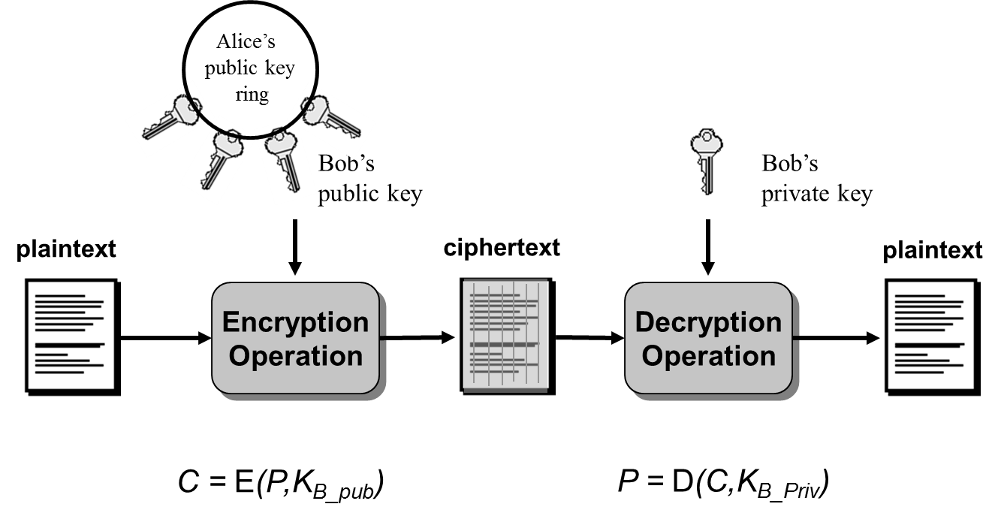

- Notation:
  - Encryption: C = E(P,K_{pub})
  - Decryption: P = D(C,K_{priv})
- The public key of the recipient is used for encryption
- The private key of the recipient is used for decryption
- Only the private key must remain confidential (i.e. known only to its owner)
  - Anyone is allowed to know the public key
  - Only the owner may know the associated private key
- Feature:
  - Ciphertext is twice the length of plaintext
  - Ciphertext is randomised – multiple encryptions of same plaintext will produce different ciphertexts

- To encrypt a message to send to Alice,
  - Bob first encodes it as a number, m.
  - Bob picks a random integer r , and computes
g^{r} mod p, (gª)^{r} = g^{ar} mod p and m x g^{ar} mod p
  - Bob sends the ciphertext (g^{r} mod p, m x g^{ar} mod p) to Alice.
- To recover the message,
  - Alice computes the shared secret (g^{r})ª = g^{ar} mod p
  - Recovers m = (m x g^{ar} mod p)/ (g^{ar} mod p)

RSA Cryptosystem
- Most well-known asymmetric cryptosystem
  - Can use for encryption, also digital signature scheme
- Based on difficulty of factorising large integers
  - Calculations performed using modular arithmetic
    - Where the modulus is product of two large primes
  - Breaking RSA is no harder than factorising the modulus (although this is a really large number – typically over 1024 bits for corporate use)

RSA Key Generation:
  - Randomly choose two large primes p and q
  - Calculate: n = pq
  - Choose a public exponent e [where e and (p-1)(q-1) have no common factors]
  - Calculate the corresponding private exponent d using the secret knowledge of primes p and q [detail outside the scope of this course]

For Authentication
- Public key is (n, e) and may be available to anyone.
- Private key (or exponent) is d and must be kept confidential
- Primes p and q must be kept confidential (possibly destroyed)
- Using asymmetric cryptography, each entity has a unique key pair:
  - One key is kept private (known only to owner of key)
  - The other key is public (anyone can know this)
- A private key can be used by the owner to form a digital signature for a particular message or file
- The corresponding public key can be used by others to verify the digital signature on the message
  - Provides authentication of the sender for a particular message
  - Since only the signer knows the private key, only the signer could have created the digital signature
- Similarities to handwritten signatures:
  - unique to signer
  - verifiable
  - legally binding

- Important differences:
  - digital signature is different for every document
  - digital signature must be produced and verified by a machine
- A digital signature is completely different from a digitized signature
- The most widely used digital signature schemes are:
  - RSA:
    - exploits symmetry in RSA encryption/decryption algorithms.
    - Relies on the difficulty of factoring large numbers.
  - DSA (Digital Signature Algorithm):
    - Also referred to as DSS (Digital Signature Standard)
    - Relies on the difficulty of solving the discrete log problem.
  - ECDSA (Elliptic Curve DSA):

Digital signatures and hash functions
- For efficiency, signature schemes typically use a hash function to reduce amount of material processed using asymmetric cipher
- To create a signature for message m,
  - first compute the hash of m, and
  - then proceed with the other steps of the signing method
- Any change in message m should result in a different hash value, so digital signatures provide some assurance of message integrity
  - Important to use the same hash function during both:
    - the signature creation process, and
    - the signature verification processes
- Digital signatures provide
  - Authentication of message sender
  - Some assurance of message integrity
- They can also provide non-repudiation:
  - A third party (judge) can decide if a specific party signed a message
  - This cannot be achieved with symmetric key authentication, such as with a MAC
  - This makes digital signatures particularly useful for electronic commerce applications

Public key crypto: spoofing problem
- Major issue associated with the use of asymmetric cryptography is the integrity and trustworthiness of public keys:
  - How can a user be sure who a public key belongs to?
  - How can a user be sure a public key has not been altered - intentionally or unintentionally?
- How can public keys be made available in a trusted way?
  - Use digital certificates issued by a trusted third party
    - a Certification Authority (CA).

Digital certificates
- Digital certificates solve the issue of binding a public key to an entity
  - one of the major legal issues with this technology
- A digital certificate contains:
  - the user’s public key
  - plus the user’s ID
  - plus some other information e.g. validity period
- A Certificate Authority (CA) creates and digitally signs the certificate
  - The CA is vouching for the information

- Format for digital certificates: X.509 standard
  - Most widely used standard (still evolving: now v3)
  - Recommended by International Telecommunication Union (ITU-T)
  - Important fields in X.509 digital certificates are:
    - Version number
    - Serial Number (set by the CA)
    - Signature Algorithm identifier (Algorithm used for dig sigs)
    - Issuer (Name of the CA)
    - Subject (Name of entity to which certificate has been issued)
    - Public Key Information
    - Validity period (certificate should not be used outside this time)
    - Digital signature (of the certificate, signed by the CA)
- How does Alice obtain a digital certificate for her public key?
  - Alice generates a key pair (keeps the private key secret) and sends to the CA:
    - her identity details, ID_{A}
    - her public key, K_{A_pub,} and
    - any other information required by the CA
  - The CA then:
    - performs any required checks to verify Alice’s identity,
    - creates a certificate containing ID_{A} and K_{A_pub}
    - sends the certificate, Cert_{A}, to Alice
  - To trust a certificate, you need to trust the CA that issued the certificate has performed the necessary checks
- How do I use Alice’s digital certificate?
- Suppose Bob wants to send a confidential message to Alice: C = E(M, K_{A_pub})
  - Bob obtains Alice’s public key for encryption:
    - Bob obtains Cert_{A}
    - Bob verifies Cert_{A}
    - Bob obtains K_{A_pub} from Cert_{A}
  - Bob uses K_{A_pub} to encrypt the message M
- If Bob:
    - trusts the CA that issued Cert_{A} and
    - is certain of the CA’s public key
    - then Bob can be sure that only Alice will be able to decrypt the ciphertext message he sends to Alice
- How do I use a digital certificate?
- Suppose Alice sends a digitally signed message to Bob: {M, SigA, CertA}, then Bob can verify it:
  - Bob obtains Alice’s public signing key:
    - Bob obtains Cert_{A}
    - Bob verifies Cert_{A}
      - uses the CA’s public key to verify the CA’s signature on CertA
    - Bob obtains K_{A_pub} from Cert_{A}
  - Bob uses K_{A_pub} to verify Sig_{A}
- If Bob:
  - trusts the CA that issued Cert_{A} and is certain of CA’s public key,
  - and if the signature verification is OK
  - then Bob has a valid signature on the message from Alice
Digital certificates and Trust:
- Q: Can I trust Alice’s digital certificate?
- A: Do I trust the CA who issued it - and is that really the CA’s public key?

Public Key Infrastructure
- Public key cryptography needs a Public Key Infrastructure (PKI) to provide security services
- A PKI is a set of
  - Policies (to define the rules for managing certificates)
  - Products (hardware and/or software) (to implement the policies and generate, store and manage certificates)
  - Procedures (related to key management)
that enable users to implement public key cryptography - often in large, distributed settings
- Critical component of a PKI is the Certification Authority (CA)
  - The CA creates and issues digital certificates to other parties
  - The level of trust you can place in a certificate depends on the amount of checking a CA does to establish the credentials of requester before providing a certificate
- Who is the CA?
  - Some large organisations have their own CA
  - Commercial CA’s charge to provide certificates, and may offer various grades
    - More thorough checking generally means greater cost

PKI: trust models
- Trust relationships
  - between different Certificate Authorities, and
  - between Certificate Authorities and end users,
define PKI trust models
- Common PKI Trust models are:
  - Hierarchical
    - Strict hierarchical
    - Distributed trust architectures
  - User-centric
  - Browser

Strict Hierarchical Model
  - Tree structure:
    - Single root CA
    - Users are leaves of the tree
    - Each node is certified by its immediate parent CA
  - Highly regulated:
    - Each CA must follow rules regarding to whom they may issue certificates
  - Root CA:
    - Starting point for trust
    - All users trust the root CA, and must receive its public key through a secure out-of-band channel
- Advantages:
  - works well in highly-structured setting such as military and government
  - unique certification path between two entities (so finding certification paths is trivial)
  - scales well to larger systems
- Disadvantages:
  - need a trusted third party (root CA)
  - ‘single point-of-failure’ target
  - If any node is compromised, trust impact on all entities stemming from that node
  - Does not work well for global implementation (who is root TTP?)

Distributed trust hierarchical architectures:
  - Interconnection of multiple hierarchies
  - No single root CA, multiple cross-certified root CAs
  - Trust is distributed among the root CAs

User-centric model
  - Each user has a key ring containing public keys of other users they trust
  - Users are completely responsible for deciding which public keys to trust
  - Public keys can be distributed by key servers and verified by fingerprints
  - Each user may act as a CA, signing public keys that they will trust
  - OpenPGP Public Key Server: http://pgpkeys.mit.edu/
- Advantages:
  - Simple and free
  - Works well for a small number of users
  - Does not require expensive infrastructure to operate
  - User-driven grass roots operation
- Disadvantages:
  - Relies on human judgment
    - Works well with technical users aware of the issues, but not general public
  - Not appropriate for trust-sensitive areas such as finance and government

Browser model

  - Used by most well-known browsers including Mozilla Firefox and Microsoft Internet Explorer
  - Some CA certificates pre-installed in the browser
    - Installed certificates are used as trusted ‘root’ CA certificates for verifying incoming certificates
  - The browser user is trusting the browser vendor who supplied the installed certificates, rather than a root CA
  - May also include list of ‘untrusted’ certificates
    - Check your browser certs for the fraudulent Comodo and DigiNotar certs revoked in 2011

Lecture 8 - Network Security
- Communication Protocols
  - Are sets of standard rules required for data representation, authentication, error detection etc. to send information over communications channels
  - The protocols permit the communications themselves to be separated from the communication media
    - Communication is independent of whether the media is coax cable, optical fibre, wireless, etc

  - Layered architecture for communications
    - Each layer performs different activities required to enable communications
  - ISO Open Systems Interconnection (OSI) model consists of 7 layers:
    - Application: User level data
    - Presentation: Data standardisation, blocking, compression
    - Session: Message sequencing
    - Transport: Flow control, error detection and correction
    - Network: Routing, blocking messages into uniformly sized packets
    - Data Link: Separating packets into frames, error recovery
    - Physical: Actual communication – bit transmission
  - Transmission Control Protocol/Internet Protocol (TCP/IP) can be considered as four layers:
    - Application: Prepares messages from users
    - Transport: Converts messages to packets
    - Internet: Converts packets to datagrams
    - Physical: Transmission as bits
  - TCP packet: data structure containing information such as sequence number, source and destination port numbers, data
  - Different applications have different port numbers. For example:
    - HTTP – port 80
    - SMTP – port 25
- Network-related security protocols in common use include:
  - HTTP Authentication:
Commonly used to authenticate users before allowing access to web content.
  - Transport Layer Security (TLS):
Used extensively on the web and is often referred to in privacy policies as a means of providing confidential web connections.
  - IP Security (IPSec):
Provides security services at the IP level and is used to provide Virtual Private Network (VPN) services.
- Hypertext Transfer Protocol (HTTP) is an application layer protocol
  - Resources are identified using Uniform Resource Locators (URLs)
- HTTP is a request/response protocol:
  - Clients (web browsers) request access to a resource, servers (computers hosting the requested web sites) respond to the request
  - 4xx status codes in responses intended to inform the client of request errors
  - Example: 404 Not found

HTTP: Basic authentication
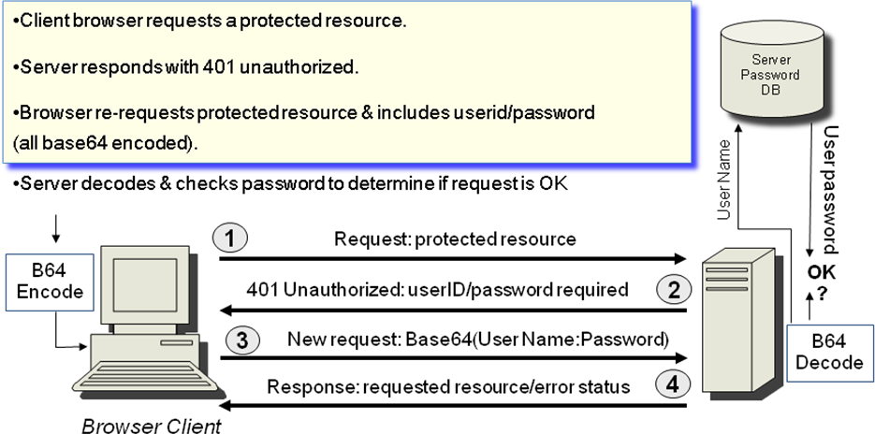

- User needs to supply user-ID and password for each realm for which authentication is required.
- Server will service the request only if it can validate the user-ID and password for the protection space of the Request-URI.
- When an unauthorized request for a URI within the protection space is received, the origin server MAY respond with a challenge like the following:
WWW-Authenticate: Basic realm=“SecretSpace”
where “SecretSpace" is the string assigned by the server to identify the protection space of the Request-URI.

HTTP: Basic authentication security
- Serious Problem:
  - Response from client includes user ID and password, base64 encoded.
  - Essentially, this is cleartext transmission of the user's password over the physical network – not very secure.
  - Sniffers can capture the userid and password
  - ‘Fake’ web servers can spoof a ‘real’ server and entice users to send their userids and passwords.
- Therefore, Basic authentication should not be used (without enhancements) to protect sensitive or valuable information transmitted over insecure channels.

HTTP: Digest authentication
- Digest authentication scheme does not transmit an unprotected password.
- Instead, it uses a simple challenge-response paradigm:
  - The challenge is a nonce value (randomly chosen and used only once).
  - A valid response contains an MD5 hash of values such as the username, the password, the given nonce value, the HTTP method, and the requested URI.
  - The response is sent as the Request-Digest field.
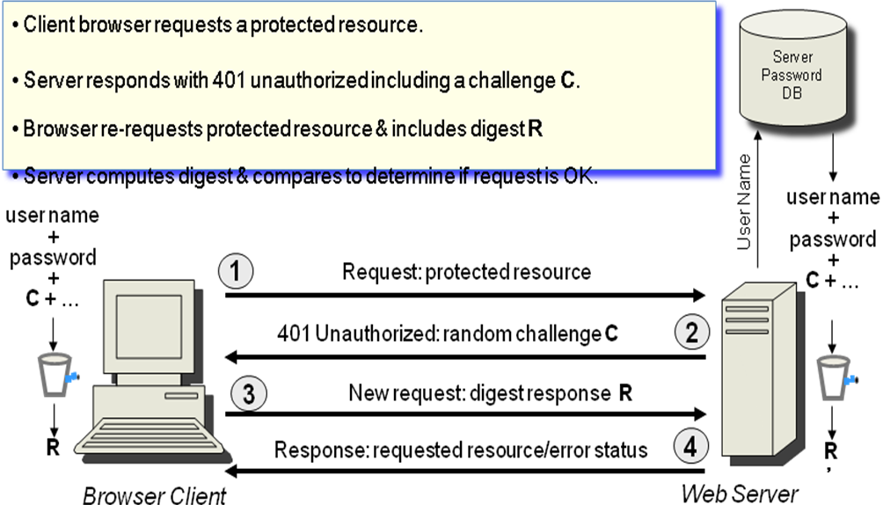

HTTP: Digest authentication security
- Digest authentication does not transmit an unprotected password
- However, an eavesdropping attacker may be able to calculate a password by using an online dictionary attack:
  - Attacker has a list of common passwords (dictionary).
  - Dictionary is usually much smaller than the total number of possible passwords.
  - Attacker captures nonce/response pairs
  - For the given nonce, the response for each password in the dictionary is determined and compared to the captured response value.

- The server can mitigate this attack by not allowing users to select weak passwords.
- Man-in-the-middle attacks
- Both Basic and Digest authentication are vulnerable to man-in-the-middle (MITM) attacks

Storing passwords
- Both schemes rely on the user/client providing a password and the server ‘checking’ this password.
  - Basic: Server decodes to recover the password and compares to the entry in its password database.
  - Digest: Server computes a hash value and compares this to the received value. The ‘password’ file contains the hash of the username, realm and password.
  - Username and password must be prearranged – how this should be done is not addressed by RFC2617.
- The password file stored on the server must be secured. If compromised, an attacker can use this information to gain access.

- Basic authentication used alone is not a secure method for performing user authentication over insecure channel.
- Digest authentication is better than Basic authentication, but still weak compared to public-key based mechanisms
- Digest Authentication has very limited integrity services.
  - “Many needs for secure HTTP transactions cannot be met by Digest Authentication. For those needs TLS or SHTTP are more appropriate protocols. In particular Digest authentication cannot be used for any transaction requiring confidentiality protection.” RFC 2617

SSL/TLS
- Transport Layer Security (TLS) is a cryptographic protocol that operates at the transport layer (actually, above the transport layer)
  - Say, on top of Transmission Control Protocol (TCP)
- Uses encryption and PKI to provide protection for network communication protocols operating at higher levels
  - For example, to protect HTTP communications
  - Use X.509 certificates to obtain public keys
  - Can be used to provide confidentiality and authentication

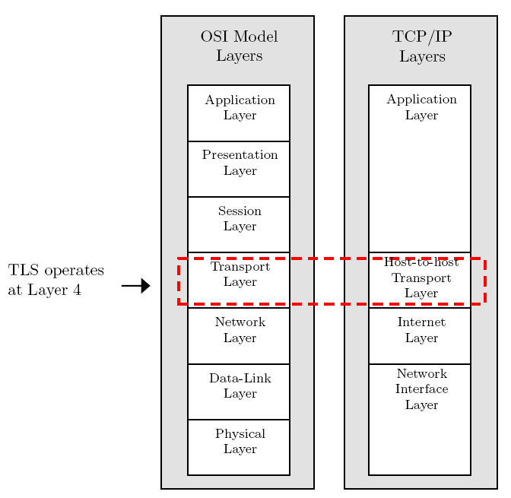
TLS

- Encryption and authentication layer added to the protocol stack between TCP and applications.
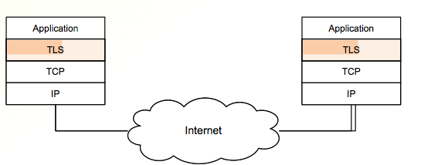

- SSL/TLS is the most commonly used encryption standard for Internet communications
  - Fast adoption because it is built into web browsers – Safari, Firefox (TLSv1.0), IE8 (TLSv1.2)
  - Intended to facilitate web commerce - used to encrypt credit card numbers and passwords sent to web sites
- TLS can be used to provide protection for HTTP communications:
  - Port 443 is reserved for HTTP over TLS
  - HTTPS is the name of the URL scheme used with this port.

  - http://www.develop.com implies the use of standard HTTP using port 80.
  - https://www.develop.com implies the use of HTTP over TLS using port 443.
- TLS Handshake Protocol: When establishing a TLS connection, the client and server must establish the version of TLS and the CipherSuite – a set of cryptographic algorithms that will be used to secure transmissions
- TLS Record Protocol: the format for TLS records to provide basic services to higher level protocols
- Other TLS Protocols include:
  - TLS Alert Protocol – error messages
  - TLS Change Cipher Spec Protocol – turn on encryption or update keys

TLS: Simplified Handshake - RSA-based
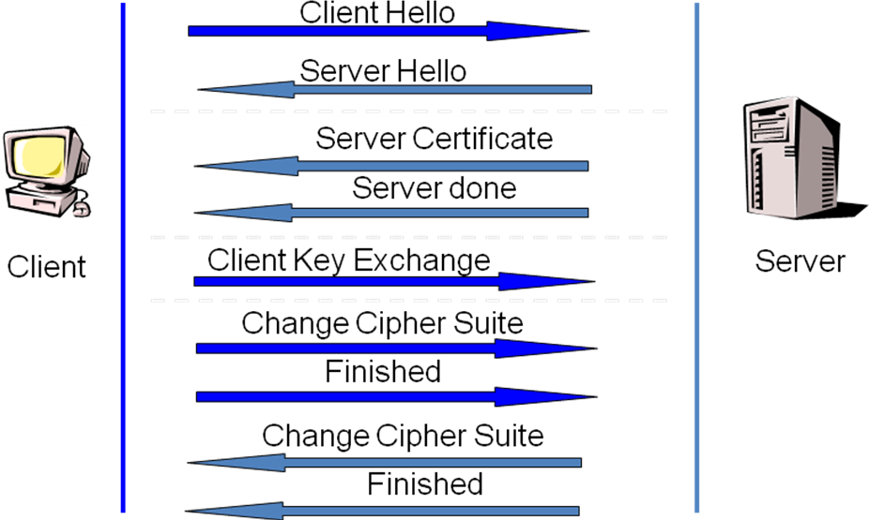

- Client hello
  - Advertises available cipher suites
  - Most common cipher suite: RSA for key establishment, 3DES for encryption and HMAC-SHA1 for data authentication)
- Server hello
  - Returns the selected cipher suite (choose from list sent by client)
  - Server adapts to client capabilities
- Server Certificate
  - X.509 digital certificate sent to client.
  - Client verifies the certificate including that the certificate signer is in its acceptable Certificate Authority (CA) list.
  - Now the client has the server’s certified public key.
- Server done
  - To indicate that the server has finished sending messages.
- Client Key Exchange
  - Client selects a random ‘pre-master secret’
  - Client encrypts the ‘pre-master secret’ using the server’s public key
  - Client sends the encrypted ‘pre-master secret’ to the server.
  - Server decrypts using its private key to recover the ‘pre-master secret’.
  - Both parties now compute the master secret using the pre-master secret and other exchanged values.
- Completion
Both client and server exchange
  - change_cipher_spec to indicate subsequent messages are encrypted and MAC’ed
  - finished message (already protected) to complete

- Provides two services for TLS connections.
  - Message Confidentiality:
    - Ensure that the message contents cannot be read in transit.
    - The Handshake Protocol is used to establish a symmetric key to be used to encrypt SSL/TLS payloads.
  - Message Integrity:
    - Ensure that the receiver can detect if a message is modified in transmission.
    - The Handshake Protocol establishes a shared secret key used to construct a MAC.

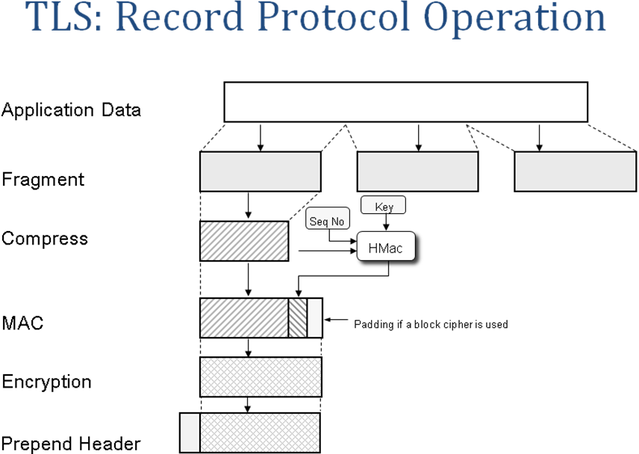

- Trust and digital certificates:
  - TLS uses public keys – provided in digital certificates
  - Certificates should be verified – requires tracing certificate pathways
  - Web browsers come with pre-configured lists of root certificates but users can add or remove root CAs
- One-way or mutual authentication?
  - Authentication is usually of server to client only, not mutual
  - Users usually do not have client certificates
  - Typically, authentication of users is not performed in handshake
  - Instead, password authentication over server-authenticated HTTPS channel

- Internet Protocol Security (IPSec) is a framework of open standards for ensuring private, secure communications over Internet Protocol (IP) networks
- Operates at the Network or Internet layer, so can secure application and transport layer communications, including arbitrary TCP and UDP sessions.
- Uses encryption, authentication and key management algorithms to provide end-to-end security
IPSec: Security Services
- Message Confidentiality.
  - Protects against unauthorised data disclosure.
  - Accomplished by the use of encryption mechanisms.
- Traffic Analysis Protection.
  - A person monitoring network traffic cannot know which parties are communicating, how often, or how much data is being sent.
  - Provided by concealing IP datagram details such as source and destination address.
- Message Integrity.
  - IPsec can determine if data has been changed (intentionally or unintentionally) during transit.
  - Integrity of data can be assured by using a message authentication code (MAC).
- Message Replay Protection.
  - The same data is not delivered multiple times.
- Peer Authentication.
  - Each IPsec endpoint confirms the identity of the other IPsec endpoint with which it wishes to communicate.
  - Ensures that network traffic is being sent from the expected host.
  - IP addresses are used as host identifiers.

IPSec: Security Services
- Message Replay Protection.
  - The same data is not delivered multiple times.
- Peer Authentication.
  - Each IPsec endpoint confirms the identity of the other IPsec endpoint with which it wishes to communicate.
  - Ensures that network traffic is being sent from the expected host.
  - IP addresses are used as host identifiers.
- Encapsulating Security Payload (ESP)
  - Confidentiality, authentication, integrity and replay protection
- Authentication Header (AH)
  - Authentication, integrity and replay protection. However there is no confidentiality
- Internet Key Exchange (IKE)
  - negotiate, create, and manage security associations
- Each protocol (ESP or AH) can operate in transport or tunnel mode.
- Transport mode:
  - Operates primarily on the payload (data) of the original packet.
  - Generally only used in host-to-host architectures.
- Tunnel mode:
  - Original packet encapsulated into a new one, payload is original packet.
  - Typical use is gateway-to-gateway architecture.

IPSec: Common Architectures
- The endpoints for communications secured using IPSec can be either hosts or gateways to secured networks.
- Combinations of these form three common architectures:
  - Gateway-to-gateway
  - Host-to-gateway
  - Host-to-host

Gateway-to-Gateway
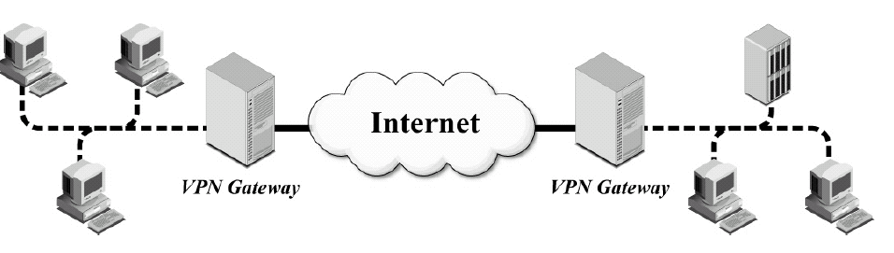

Host-to-Gateway
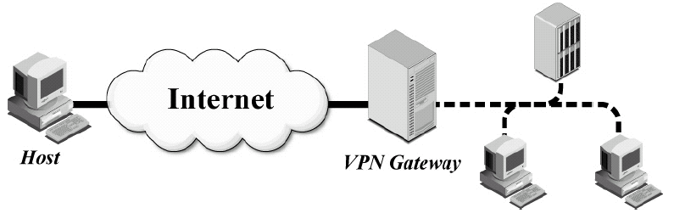

Host-to-Host
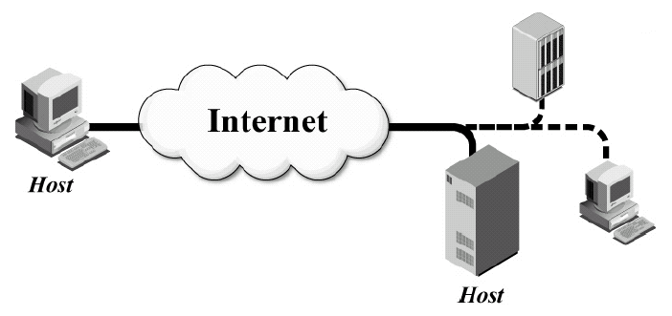

Gateway-to-Gateway
- Provides secure network communications between two secure networks. Network traffic is routed through the IPsec connection, protecting it appropriately.
- A VPN connection is established between the two gateways.
- NOTE: This only provides protection for data between the two gateways.
- Commonly used for connecting two secured networks as an alternative to the more costly private wide area network (WAN).
- Example: linking a branch office to headquarters over the Internet.

Host-to-Gateway
- Provides secure communications over an insecure connection between a single host and a secure network.
- A VPN connection is established between the host and the gateway to the network.
- NOTE: This only provides protection for data between the host and the gateway – within the network the transmissions are not protected.
- Commonly used to provide secure remote access for a single user connecting over an untrusted network to resources on a secure company network.
- Example: providing access over the Internet for employee working from home (their local computer is the host) to resources located within the company headquarters.

Host-to-Host
- This is the only architecture that provides protection for data throughout its transit.
- All user systems and servers that will participate in VPNs need to have VPN software installed and/or configured.
- Key establishment is often accomplished through a manual process.
- Resource-intensive to implement and maintain in terms of user and host management
- Example: Could be used for special purpose, such as system administrators performing remote management of a single server.

IPSec: Benefits
- Is transparent to applications
  - Operates at Network/Internet layer so applications are not aware of its operation.
- If applied at a network gateway (firewall/router), strong security applies to all traffic crossing this boundary.
  - Internal workstations need not be reconfigured.
- Can be transparent to end users.
  - System administrator configures IPSec;
the end user is not involved.
Summary
- Security for web communications (http):
  - Password-based HTTP Authentication in the clear -> weak security
  - TLS: Confidentiality, Integrity and PKI-based Authentication (usually of server to browser)
  - HTTPS = HTTP over TLS
  - HTTP Authentication over server-authenticated HTTPS channel -> stronger security
  - Browser PKI trust model is weak in practice – users do not know which certificates to trust.
- Security for IP traffic: IPsec
  - Mostly used in tunnel mode for setting up VPNs

Firewalls
- Firewall: component or set of components
  - placed at the interface between two networks with differing security requirements
  - aims to control the flow of network traffic between a protected network and other networks.
- Frequently used to prevent unauthorized Internet users from accessing private networks (Intranet).
  - All messages entering or leaving the intranet pass through the firewall
  - Each message is examined, and those that do not meet the specified security criteria are blocked.
- Can be implemented in hardware, software, or a combination of both.

- Transmission Control Protocol/Internet Protocol (TCP/IP) 4 layer model:
  - Application: Prepares messages from users, sends and receives data for particular applications. Example: HTTP
  - Transport: Converts messages to packets, provides services for transporting application layer data between networks. Example: TCP
  - Network/Internet: Converts packets to datagrams, network routing. Example IPv4, IPv6
  - Physical: Transmission as bits, uses physical network components to send data through the network
- At the
  - Sending end: data passed from Application layer down to layers below, each layer adds extra information
  - Receiving end: data is passed upwards from Physical layer
- Basic firewalls examine data associated with lower TCP/IP layers only.
  - Example: Simple packet filters operating at network level
- More sophisticated firewalls can examine application layer data.
  - Example: Application level gateway

Simple packet filters
- A packet filter is a device or program that operates at the network layer
- Simple packet filters examine each packet independently of other packets
  - Even if they are part of the same connection
- The packet filter decides whether to pass or drop each packet
- Decisions based on information in packet headers, such as
  - IP header fields (Source or Destination IP Addresses)
  - The Protocol (UDP, TCP or ICMP)
  - TCP/UDP port numbers (Source or Destination Port Numbers)
  - Direction the packet is travelling (into/out of the internal network)
- Routers are commonly used as packet filters, in addition to performing normal routing duties
- Decision making can also consider the direction the packets are travelling:
  - Ingress filtering: filtering inbound traffic
  - Egress filtering: filtering outbound traffic
- To reduce the possibility of transmitting packets with spoofed addresses, a simple rule to implement is:
  - Ingress filtering: drop inbound packets with source addresses that belong to the local network
  - Egress filtering: drop outbound packets with source addresses that are not local
Stateful Packet Filters
- Stateful packet filters operate in the same way as simple packet filters
  - examining headers and comparing to ruleset to see if the packet transmission is allowed under the firewall rules
- BUT stateful packet filters are more ‘intelligent’ than simple packet filters
  - Also keep a ‘state table’ noting the state of each connection:
  - Is the connection being established, in use, or terminated?
- Stateful packet filters examine the state in the context of the of the conversation
  - If header values contradict the expected state, the packet will be dropped
- Sometimes called dynamic packet filters due to their ability to add rules ‘on the fly’.
- For example:
  - Can recognise an outgoing connection request being sent from an internal client to an external server,
  - Will add a temporary rule to allow reply traffic back through firewall.
  - When session is finished, the temporary rule is deleted.
- Common software packages for stateful packet filters include:
  - IPTables for Linux
  - Checkpoint Firewall-1
  - Cisco PIX (integrated hardware & software)
Microsoft Internet Security and Acceleration Server

Strengths:
  - Low overhead
  - High throughput
  - Operates at lower layers, so supports almost any application

Weaknesses:
  - Do not examine application layer data/commands
    - May allow insecure operations to occur
    - Cannot perform content filtering or user authentication
  - Allow direct connections between hosts inside & outside firewall
  - Simple (stateless) packet filters only:
    - less secure (can be susceptible to IP spoofing)
    - more difficult to write complex rules

Personal Firewalls
- A personal firewall is a software program that is designed to protect the computer on which it is installed.
  - Frequently used by home users to provide protection against unwanted Internet traffic.
- Usually these are stateful packet filters.

Application Proxy Gateway

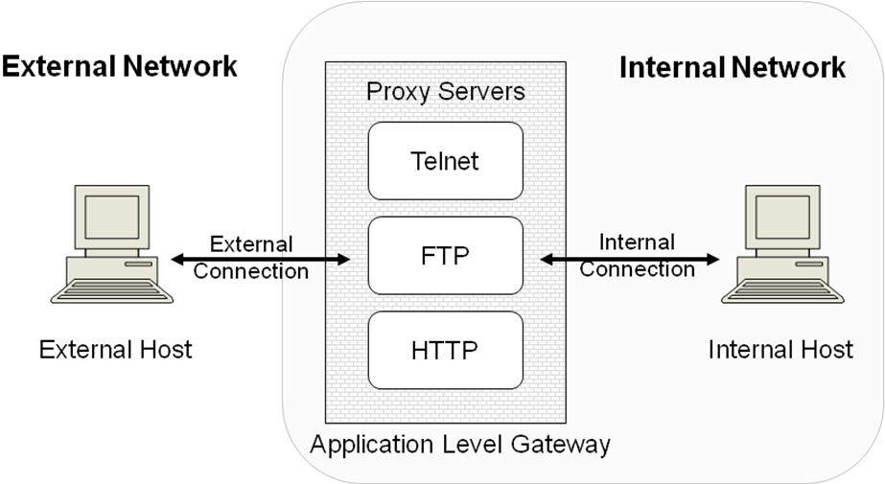

Strengths:
  - Provides potential for best security through control of application layer data/commands
  - Better logging and audit of traffic
  - Allows content filtering and user authentication

Weaknesses:
  - Slower than packet filters – requires time to examine packet data in details, so may be unsuitable for real-time applications
  - Limited support for new applications – additional time requirement for vendor to write new gateways for new applications
  - Requires one additional connection (including processing resources) for each new connection

Dedicated Proxy Servers
- To deal with load problems in an application proxy gateway dedicated proxy servers can be used
- These are typically
  - Deployed behind traditional firewall platforms
  - Dedicated to one type of traffic such as HTTP, SMTP, FTP
- Can perform authentication and audit as well as filtering for content such as:
  - Active code such as Java applets
  - Email attachments of certain types
  - Viruses

Simple Firewall Architecture
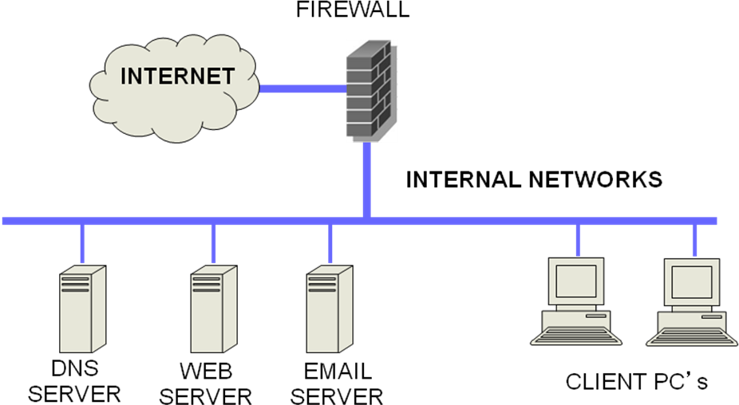

DMZ Architecture
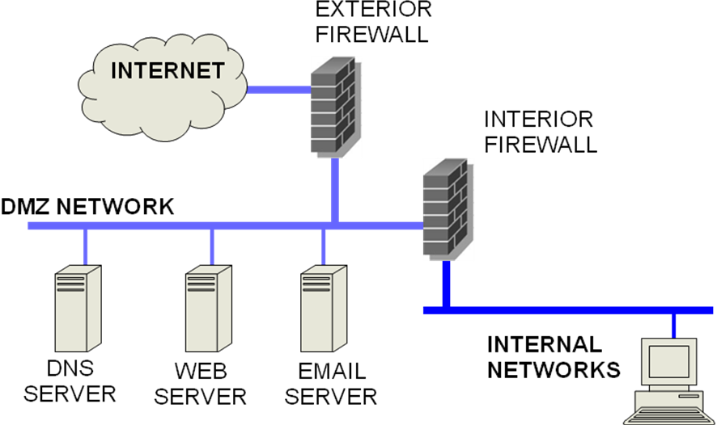

Firewall issues
- Firewalls are only effective if:
  - they are set up to implement a well formulated security policy.
  - That is, the most important aspect of a firewall is a clear conception of what it is meant to protect.
  - they are effectively administered, updated with the latest patches and monitored.
- The security policy must clearly define acceptable traffic
  - Only that traffic allowed to pass through the firewall;
  - everything else is considered unacceptable and must be blocked

- Filtering should be performed on traffic in both directions:
  - Outbound connections should be filtered to prevent:
  - internal users accessing untrusted services or dangerous content
  - compromised internal machines spreading viruses to the Internet, or being used as part of distributed attacks
- Firewall rules can be difficult to configure
  - Order of rules matters
  - Configurations are usually fragile
  - Administrators can be afraid to modify configurations in case something breaks

Lecture 9 - Digital Forensics

- Computer Crime
- What is computer crime?
  - Cybercrime, electronic crime
  - Types of crimes
    - Hacking (in the illegal sense), malware, viruses, DOS & DDOS attacks, phishing attacks
    - Copyright infringement, loss of confidential information
    - Computer based fraud
    - Child pornography, child grooming
    - Harassment, cyber bullying, cyber stalking
    - Cyberterrorism
    - Cyberwar
    - Spam
    - Drug trafficking
    - And the list goes on …

Reality of Digital Forensics
- There are no “smoking guns”
  - Evidence is circumstantial (at best) not direct evidence of a crime
- Investigators require
  - familiarity with specific OS
  - familiarity with multiple OS
  - experience with a range of tools
  - skill at organising large collections of different information
  - retrieval expertise for deleted and residual data
  - skills in court case preparation and giving evidence or opinion
- Competent analysis can take days, weeks or months
- Depends on
  - Amount of data
  - Importance of case
  - Budget
- Examiner will look at remnants of everything that is on a disk or device
  - Emails
  - Websites
  - Chat sessions
  - Phrases searched for
- Imagine if that was your disk or device…

- Criminal cases
  - Laws (state, federal, etc) broken
  - Law enforcement has detected the crime
  - Presumption of innocence
  - Prosecution must prove case otherwise
- Civil cases
  - A party claims damages of some sort (plaintiff)
  - Plaintiff must prove on the balance of probabilities that their claim is just

Computer Forensics Process
- Identify
  - Where and what is relevant evidence
- Secure
  - Remove from scene (unusual to do this now)
  - Remove people from scene
  - Record scene – still and video camera
  - To “pull the plug” or not
  - Statically linked tools
  - Copy without alteration
  - Write blockers
  - Validate and Verify – One Way Hash Functions
  - Chain of Custody
- Analyse
  - Determine meaning of evidence
  - Discover intent
  - Hash databases
  - Hidden files
  - File authorship
  - Timelining
  - Searching – keywords, file signatures
  - Password Cracking
- Present
  - Report on process and findings
  - What does it mean in context of case
  - Possibly in a court of law

- Specialist Tools Required
  - Disk and device imaging
    - Copy entire disk – not just files visible to Operating System
  - Verification tools
    - All data passed through 1 way hash (MD5, SHA1)
  - Analysis Tools
    - Forensic Suites – EnCase, FTK, Winhex, etc
    - Numerous single purpose tools
      - File viewers, Scalpel, Web browser data extraction, file recovery, Rifuiti (recycle bin analysis), Pasco (IE browser analysis)

Digital Evidence
- Any information of probative value that is either stored or transmitted in a digital form

Challenges
- Vast quantity
- Easily contaminated
- Crime may not be identified for months (years)
- May be a vast number of potential suspects

Must satisfy legal requirements
- Authentic
  - original, relate to the crime
- Reliable
  - collected properly
- Complete
  - may be used to prove guilt as well as innocence
- Believable
  - be convincing to a jury and presented so it makes sense
- Admissible
  - collected using procedures conforming to common law

Where can you get digital evidence?
  - Desktops, laptops, servers
  - PDAs
  - iPods, iPads, tablets, etc
  - Cameras, memory cards
  - Phones, phone records
  - Web browsers
  - Email servers
  - Logs and databases

What can you get?
  - Ghost (overwritten) data
    - Magnetic Force Microscopy
    - Not particularly feasible, but…
  - Garbage retrieval
    - Print spoolers, swap files, cache, recycle bins
  - Web browser information
    - Web browsing history, cache
    - Passwords!
    - Credit Card numbers!
    - Web searches!

  - Phone companies
  - Frequent Flyer programs
    - Airlines, supermarkets, retailers, etc
  - Banks, road tolls, public transport
  - Health, taxation records
    - E-tax database linking
- Complexity
  - Data acquired at lowest level
  - Needs abstraction
  - Abstracted Views
    - Physical Media – head, cylinder, sector
    - Disk Management – partition table, partitions
    - File System – boot sector, FAT, MFT
    - Application – ASCII, HTML, proprietary, databases, binary etc.

Disk Systems
- Hard disk structure
  - Platters
  - Sections
  - Tracks
  - Sector (single section of a track)
    - 512 bytes
  - Clusters (group of sectors)
    - Smallest unit available
- Files
  - Written onto one or more clusters
- Slack Space
  - What is left over at the end of a cluster

Challenges for Forensics

- Disk size
  - Imaging, analysis, searching
  - Selective imaging, arrays of analysis machines
- Devices
  - A multitude of different types
    - No standardization
    - Not designed with forensics in mind
- Encryption
  - Password cracking
    - Build password lists
    - Brute force (exponential complexity)
    - Rainbow tables

- The Cloud
  - Jurisdiction
    - Just where is the data?
  - Is the cloud forensically ready?
  - Are current procedures suitable?
- Steganography
  - Message hiding in other documents
    - Text (not common)
    - Picture files (GIFs, BMPs, JPGs)
    - Audio files (WAVs)
  - Steganographic File System
    - StegFS
      - Multiple copies of data required due to collisions
      - Currently no way of detecting its presence

